**Woodcraft Store Management System**

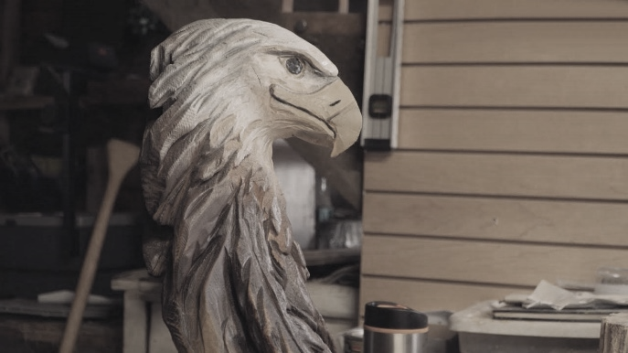

**Gagan Raj Dangol**

**00172900**

**Computing Project**

**Level 5 Diploma in Computing**

**Email:** [dangolgrozen123@gmail.com](mailto:dangolgrozen123@gmail.com)

**Softwarica College of IT & E-Commerce**

***Kathmandu, Nepal***

01/27/2019

**Submitted to**: Kiran Rana

Table of Contents

1. Introduction: 4

1.1 Justification for project 5

1.1.1 Background of the project: 5

1.1.2 Problem Statement: 5

1.2 Description of the project 6

1.2.1 Features 6

1.3 Scope and Limitation of project 7

1.3.1 Scope: 7

1.3.2 Limitation: 7

1.4 Aims and Objectives 7

1.4.1 Aims: 7

1.4.2 Objectives: 7

2. Development Methodology 8

2.1 Methodology used 8

2.2 Design Pattern 10

2.3 System Architecture 11

3. Work Breakdown Structure (WBS) / Scheduling 12

3.1 Work Breakdown Structure (WBS): 12

3.2 Scheduling/Gantt Chart: 13

4. Risk Management: 15

5. Configuration Management: 16

6. Requirement Analysis: 16

6.1 Functional and Non-Functional: 16

7. Design 18

7.1 USE CASE DIAGRAM 18

7.2 Class Diagram: 21

7.2.1 Initial Class Diagram: 22

7.2.2 Final Class Diagram: 23

7.3 ER Diagram: 24

25

7.4 Activity Diagram: 26

7.5 Sequence Diagram: 29

8 Prototype: 32

1. UI Design: 32

2. Conclusion: 37

3. References 37

**List of Figures:**

Figure 1: Use Case Diagram 8

Figure 2: Initial Class Diagram 10

Figure 3: Final class diagram 11

Figure 4: ER Diagram 13

Figure 5: Login Activity Diagram 15

Figure 6: Item Activity Diagram 16

Figure 7: Bill Activity Diagram 17

Figure 8: Login Sequence Diagram 19

Figure 9: Bill Sequence Diagram 19

Figure 10: Item Sequence Diagram 20

Figure 11: Login Page Prototype 21

Figure 12: Sign Up Page Prototype 21

Figure 13: Home Page Prototype 22

Figure 14: Gallery Page Prototype 22

Figure 15: Bookings Page Prototype 23

Figure 16: Categories Page Prototype 23

Figure 17: About Us Page Prototype 24

Figure 18: Admin Page Prototype 24

Figure 19: Home Page User Interface 25

Figure 20: Gallery Page User Interface 25

Figure 21: Bookings Page User Interface 26

Figure 22: Categories Page User Interface 26

Figure 23: Sign Up Page 27

Figure 24: Billing page 27

Figure 25: About Us Page User Interface 28

Figure 26: Login User Interface 28

Figure 27: Sign Up User Interface 29

# Chapter 1 : Introduction:

Woodcraft Store Management System is a web-based application software that focuses on providing its customers with best web-services. Moreover, e-commerce facilities and also other services that facilitates stock management, information gathering, etc.

Laravel is a PHP framework for developing web-base and desktop applications and is object oriented. For the development of Handicraft Store Management system, I chose Laravel.

## Problem Background to the system

The transactions held on the store were based on bills and receipts. Customers order products either by telephone or going into the store. Recordkeeping is paper-based and recorded into registers and files. This led to tenuous working environment. Growing business and customers made it difficult to manage the records.

The sole purpose of this project is to develop a web-application that computerizes above tasks. The application enables customers/users to engage with the store using their phone and computers and held daily transactions, as similar to an e-commerce site. Use of database tools leads to proper management and safety of records. Thus, the project will help in overcoming these difficulties.

* 1. **Justification**

### Aims

The major aims of the project are:

* To automate and simplify daily transaction of the store
* Keeping the business relations intact
* Keep the customers/users engaged with the store

### Objectives:

To obtain above goals following objectives are to be considered:

* perform analysis and gather requirements
* create user friendly interface
* design database
* perform testing
* perform maintenance
* provide online shopping services
* produce a well-documented report
* design logical and physical diagrams
* Performing proper Testing
* Performing Maintenance

### Over view of the project design

Woodcraft and its collection is a hobby for many people. Handmade crafts are valued even more. People are less aware of the varieties of products that the store possesses and most people are not even aware of the traditional values that woodcarving carries along with it. It is within the aim of the store to publicize and promote their products but primarily maintain and manage their daily transactions held with their customers and wholesalers.

This project is ought to help complete this aim. It leads to a web-based application that lets the customers to place product-order, bill-order and others through internet. It also allows customers to instantly get information and share if needed, which can contribute in publication and promotion of woodcarving. It also informs the users/customers and wholesalers about ongoing activities. The project ensures to develop an application that is convenient to use and in a way that the users are motivated to keep engaging with the store.

## Description of the project

### Features

The features of the project are as follows:

* **User login**

Customers or people can create personal accounts and start ordering as soon as it is created.

* **Product Shop**

Soon as the account is created, users can place order and shop products.

* **User Cart**

Users can add products to their cart and view later on.

* **Product Review & Rating**

Users can rate and comment and share their views regarding to the product.

* **Product Gallery**

Hundreds of woodcraft products are listed along with their picture and details.

* **Forum**

Users can post status and comment on them within the application.

* **Admin Login**

Admin, which is mostly the member of the store, can create an admin account and manage the application.

* **Inventory**

Admin can perform inventory management to manage product stock.

* **Billing System**

Admin can create bill, receipts and necessary papers.

## Scope and Limitation of project

### Scope:

hnb

### The project covers different sectors through the application. It helps to promote local goods to different regions. It also attracts international and domestic tourists. It helps enhancing different business areas which includes art galleries, museums, etc. It influences people into design and decoration.

### Limitation:

The project is limited to certain factors. This project doesn’t allow online payment services. Even though the application is publicly view and used internationally, goods cannot be shipped or delivered internationally. Most of the services are limited to domestic regions.

# Development Methodology

## Methodology used

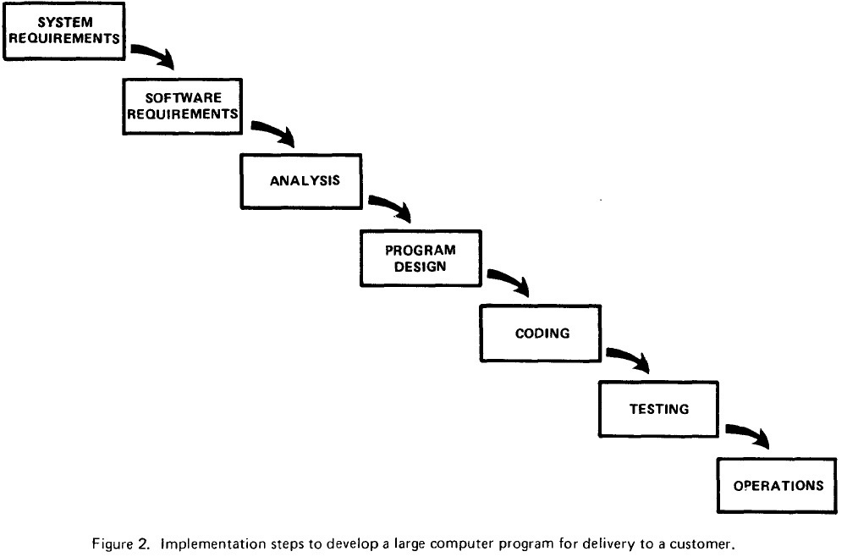For the development of this project, I have chosen Waterfall Model method. It is very simple to understand and use. In this model, each phase must be completed before the next phase can begin and there is no overlapping in the phases. **Hence, I chose this method because** Waterfall model works well where requirements are very well understood.(Waterfall Model, n.d.)

**Requirements:** All the possible requirements are analyzed and documented for the system to be developed for the software.

**System Design:** The system design is prepared or documented according to the specification of requirements analysis.

**Implementation:** Each unit is developed and tested for its functionality which is referred to as Unit Testing.

**Testing:** All the units developed in the implementation phase are integrated into a system after testing of each unit. The product is tested to find the bugs or issues and solves them.

**Deployment:** Once the functional and non-functional testing is done, the product is deployed in the customer environment or released into the market.

**Maintenance:** Modifications arises either due to change requests initiated by the customer, or defects uncovered during live use of the system.

## Design Pattern

In this project I will be working on MVC (Model-View-Controller) design pattern using PHP (Laravel) framework. Model to represent an objects, view to represent the visualization of the data that model contains and controller to control the data flow into model object and updates the view whenever data changes. The MVC pattern with Laravel framework functions as shown below:

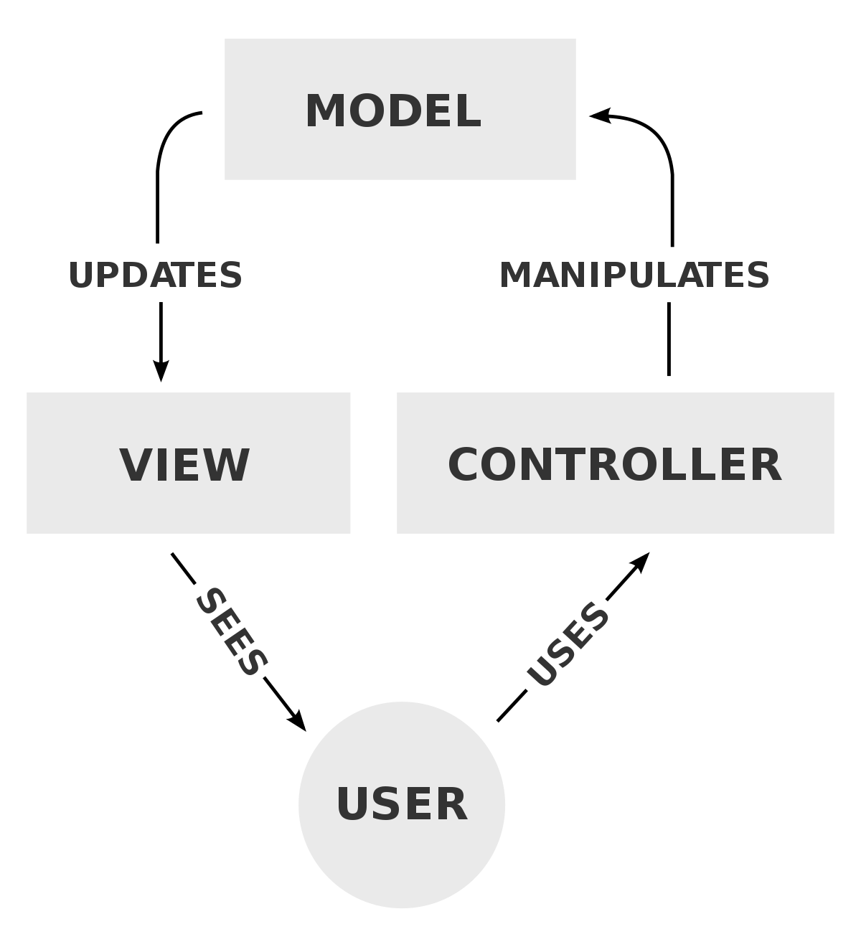

## System Architecture

I am going to use 3-tier architecture in this project. It separates the application into three major parts UI, Business Logic and Data Storage.

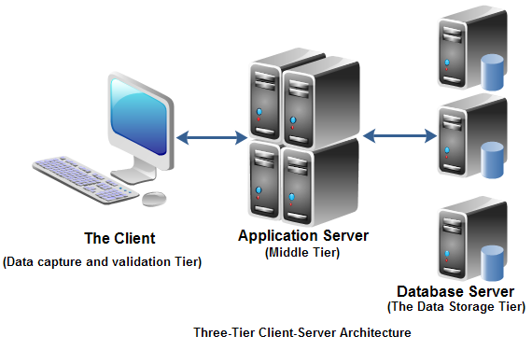

# Work Breakdown Structure (WBS) / Scheduling

Here, the project plan is described and shown in various ways. Microsoft word 2013, Project Libre 1.8 etc. are used for project plan.

## Work Breakdown Structure (WBS):

WBS is a hierarchical and incremental decomposition of the project into phases, deliverables and work packages. It is a tree structure, which shows a subdivision of effort required to achieve an objective (wikipedia, n.d.). A work breakdown structure helps to plan my work more efficiently.

## **Scheduling/Gantt Chart:**

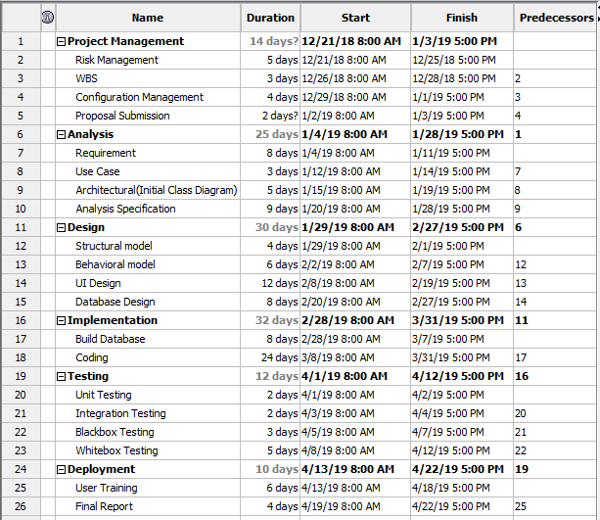The time schedule for my project is represented in a diagram of Gantt chart with milestones.

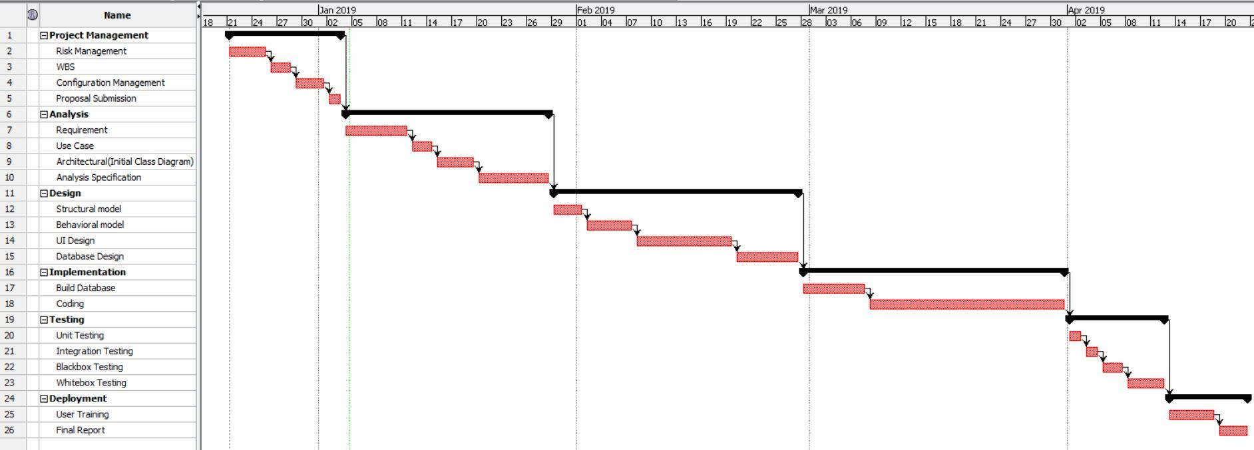

# **Risk Management:**

Nothing is secure in the internet today. There are various types of threats or risks in using the internet. Some of the risks are identified that can be with my product are listed below using tabular form.

To estimate the impact of each identified risks we use:

***Impact = Likelihood × Consequence***

In this relation, the likelihood and consequence values are assigned based on the scale shown below:

|  |  |
| --- | --- |
| **Likelihood** | **Value** |
| Low | 1 |
| Medium | 2 |
| High | 3 |

|  |  |
| --- | --- |
| **Consequences** | **Value** |
| Very Low | 1 |
| Low | 2 |
| Medium | 3 |
| High | 4 |
| Very High | 5 |

|  |  |  |  |  |  |
| --- | --- | --- | --- | --- | --- |
| **S. No** | **Risk** | **Likelihood** | **Consequences** | **Impact** | **Action** |
|  | Ransomware | 1 | 5 | 5 | Proper data Backup System. |
|  | Denial of service attack | 2 | 4 | 8 | Deployment of reputable antivirus and firewall |
|  | Server failure | 2 | 3 | 6 | Suitable environment |
|  | Phishing | 2 | 2 | 4 | Awareness and use of anti-phishing tools. |
|  | Insecure third party services | 3 | 3 | 9 | Use of cryptography. |
|  | Disk crash | 2 | 4 | 8 | Appropriate disk and proper backup. |
|  | Insufficient Features | 1 | 2 | 2 | Proper analysis is to be done. |

# **Configuration Management:**

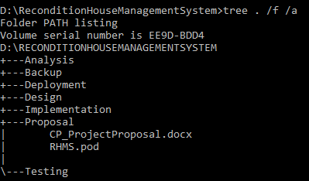The process of keeping and tracking the detail data, so the updates can flow with the existing project. Files and folder should be safely stored in a systematic order, so that it can be easily excessed whenever we need to. When configuration management is done, the consistency of the projects becomes better. The given figure shows the configuration management of my project:

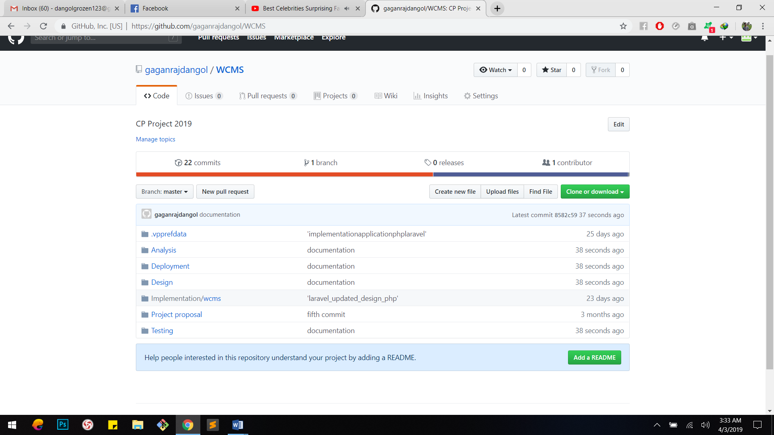

# Requirement Analysis:

## Functional and Non-Functional:

Functional requirements are the requirements that specifies a particular behavior of function of the system when certain conditions are met .It defines what a system is supposed to do.

Non-Functional requirements are the requirements that specifies criteria that can be used to judge the operation of a system, rather than specific behaviors. It defines how a system is supposed to be. (Anon., n.d.)

In the below table, the functional and non-functional requirements are identified and also they are prioritized with MoSCoW prioritization.

Indexes used in the table below are:

**F**=Functional requirements

**NF**=Non-Functional requirements

**M**=Must Have

**S**=Should Have

**C**=Could Have

**Functional Requirements Table with MoSCoW prioritization:**

|  |  |  |  |
| --- | --- | --- | --- |
| **S. No** | **Requirements** | **MoSCoW** | **Description** |
|  | Login | **M** | Login is necessary to verify and validate the users (All the users). |
|  | Registration | **M** | User (Not for admin) should be registered in order to get access. |
|  | Insert Item | **M** | Items are to be inserted by admin only to provide the available items for users. |
|  | Update Item | **S** | Items information should be able to be updated by the admin only. |
|  | Delete Item | **S** | Admin should be able to delete the unavailable items. |
|  | View Item Information | **M** | Both admin and users should be able to view item information. |
|  | Book Item | **M** | Users (Not for admin) should be able to book items they want. |
|  | Search Item | **S** | Items should be able to view information in search if the item exists. |
|  | Home Page | **S** | Home page should be available after the user authentication is verified. |
|  | Edit Profile | **S** | Users (All the users) should be able to edit their profile or information. |
|  | User Review | **C** | User review is useful to know the product’s quality. |
|  | Log Out | **M** | Users should be able to logout their account for their security. |
|  | Generate Bill | **M** | Users are provided bills after they buy the products. Therefore, bill should be able to be generated. |
|  | Forgot Password | **C** | It is one of the good factor that increases the customer satisfaction. User sometimes forgot their passwords, in that case it is very useful. |
|  | Contact Information | **S** | Contact information are provided to the users in order to provide communication service. |
|  | Visitor Counter | **C** | It is just used for analysis purpose that counts how many times the site is visited. |
|  | Manage Inventory | **M** | Inventory system of the data should be managed in a proper way that reduces the future risks. |

**Non-Functional Requirements Table with MoSCoW prioritization:**

|  |  |  |  |
| --- | --- | --- | --- |
| **S. No** | **Requirements** | **MoSCoW** | **Description** |
|  | Security | **S** | Users should be provided security for their accounts, activities they perform, and also the data in the system. |
|  | Performance | **S** | User should not feel that the system (server) is slow. There are many options to increase the performance. |
|  | Availability | **S** | The system should be available to the users whenever they want. |
|  | Reliability | **S** | The system should be reliable to the users no matters what or how many time they performs any activities. |
|  | Maintainability | **S** |  |
|  | Usability | **S** |  |
|  | Data Integrity | **S** |  |
|  | Supportability | **S** |  |

Table 2: Non-Functional Requirements

# Design

## USE CASE DIAGRAM

A **use case diagram** is a representation of a user's interaction with the system that shows the relationship between the user and the different use cases in which the user is involved. To build the use case diagram, a set of specialized symbols and connectors are to be used. (Anon., n.d.)

**Justifications:**

The use case diagram describes a set of actions that some system can perform in collaboration with one or more external users of the system, gather the requirements of a system, identifies and clarifies the relationships between and among the actors and the use cases and identifies the external and internal factors influencing the system.

**Advantages:**

* It helps to collect the functional requirements of a system.
* It can serve as the basis for the estimating, scheduling and validating effort.
* It can also collect additional behavior that can improve system robustness.

**Disadvantages:**

* They do not capture the non-functional requirements easily.
* Difficult to manage scenario.
* It has poor identification of structure and flow.

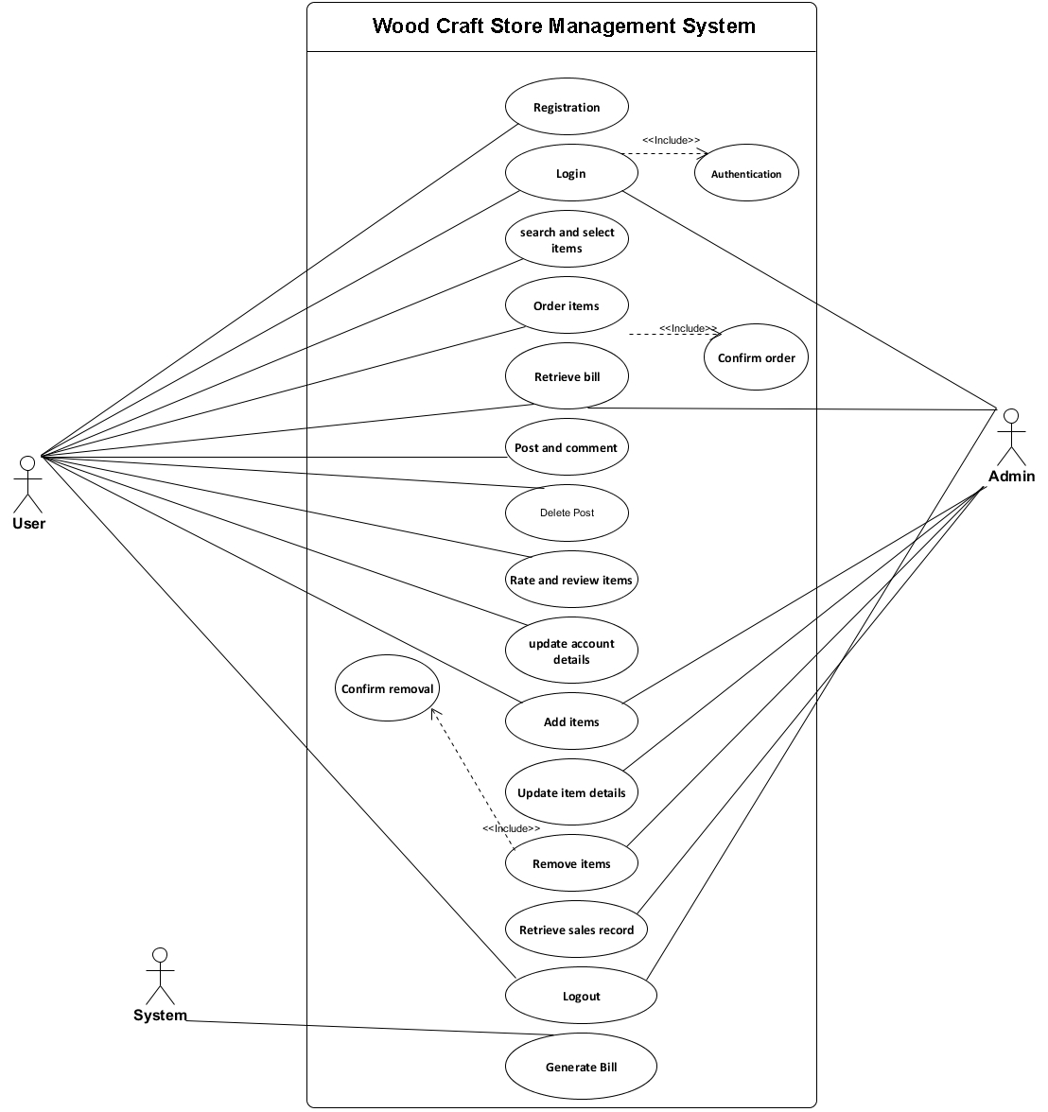

Figure 1: Use Case Diagram

# Chapter 3: Design

## Justification

## Dynamic Modeling

### Sequence Diagram:

Sequence Diagrams are interaction diagrams that detail how operations are carried out. Sequence Diagrams show elements as they interact over time and they are organized according to object (horizontally) and time (vertically). The sequence diagram is used primarily to show the interactions between objects in the sequential order that those interactions occur.

**Justifications:**

Here, I have drawn sequence diagram to show the high-level interaction between active objects in a system, model the interaction between object instances within a collaboration that realizes a use case, the interaction between objects within a collaboration that realizes an operation and to show all the possible paths through the interaction.

**Advantages:**

* The sequence diagram may be used in object-oriented analysis to validate class diagrams against use cases, or to show the timing of interactions between entities within the system scope.

**Disadvantages:**

* A sequence diagram must be defined for each possible scenario. Strictly speaking, a sequence diagram requires a fully defined class model.

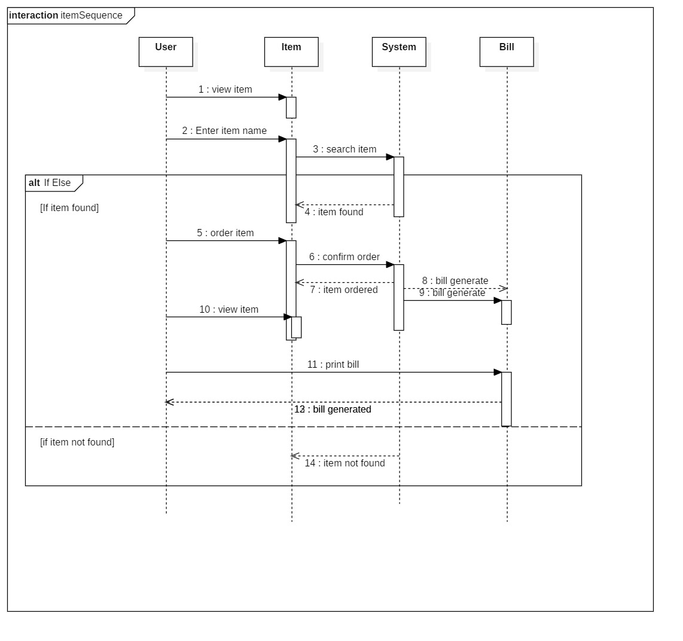

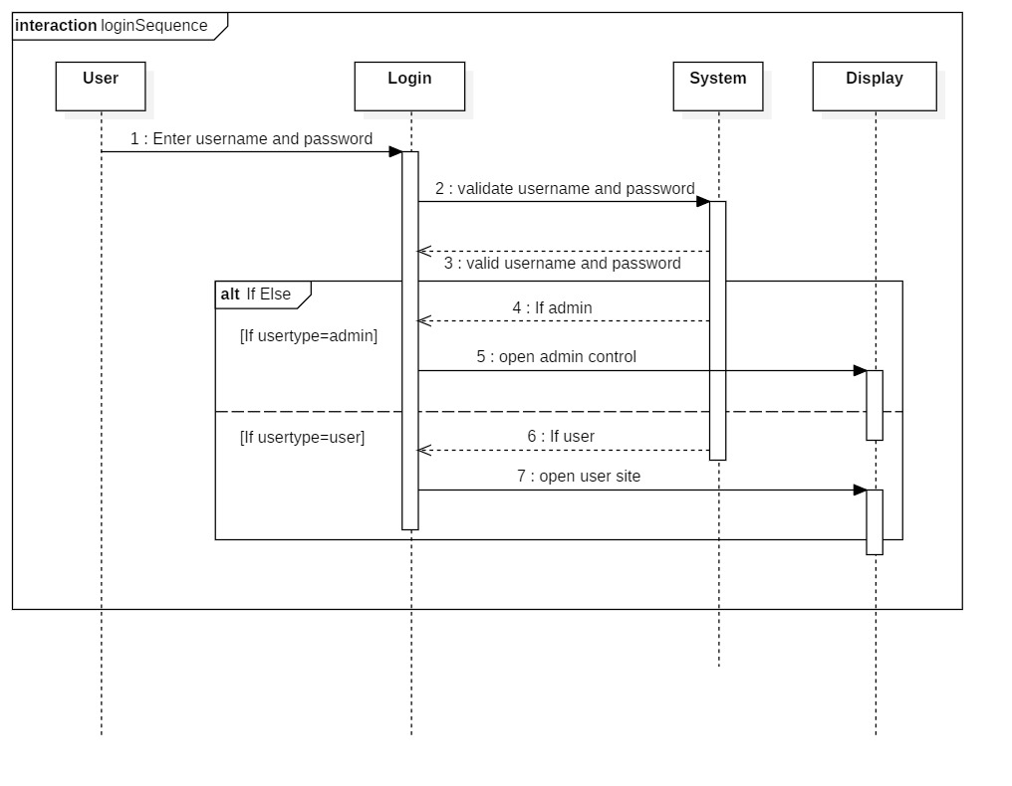

### Activity Diagram:

An **activity diagram** is a graphical representation of an executed set of procedural system activities and considered a state chart diagram variation. Activity diagrams describe parallel and conditional activities, use cases and system functions at a detailed level. (Anon., n.d.)

**Justifications:**

Here, I have drawn activity diagram to show message flow from one activity to another. It captures the dynamic behavior of the system. It is also used to draw the activity flow of a system, to describe the sequence from one activity to another, and to describe the parallel, branched and concurrent flow of the system.

**Advantages:**

* Since it is the most user-friendly diagram. So, generally regarded as an essential tool.
* It helps to display multiple conditions and actors within a work flow through the use of swim lanes.
* These diagrams are normally easily comprehensive for both analysts and stakeholder.

**Disadvantages:**

* These diagrams can lead the over complex which might affect the user-friendly nature.
* These diagrams do not give the detail about how object behave or collaborate.

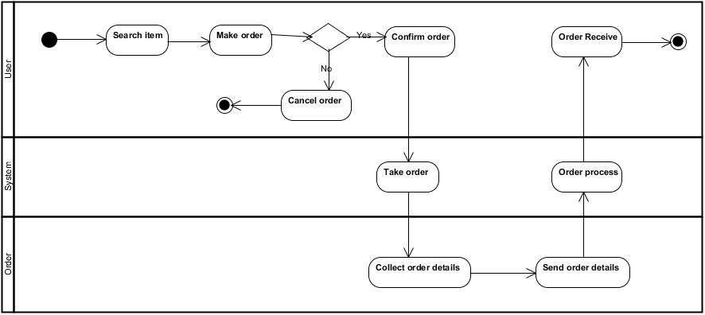

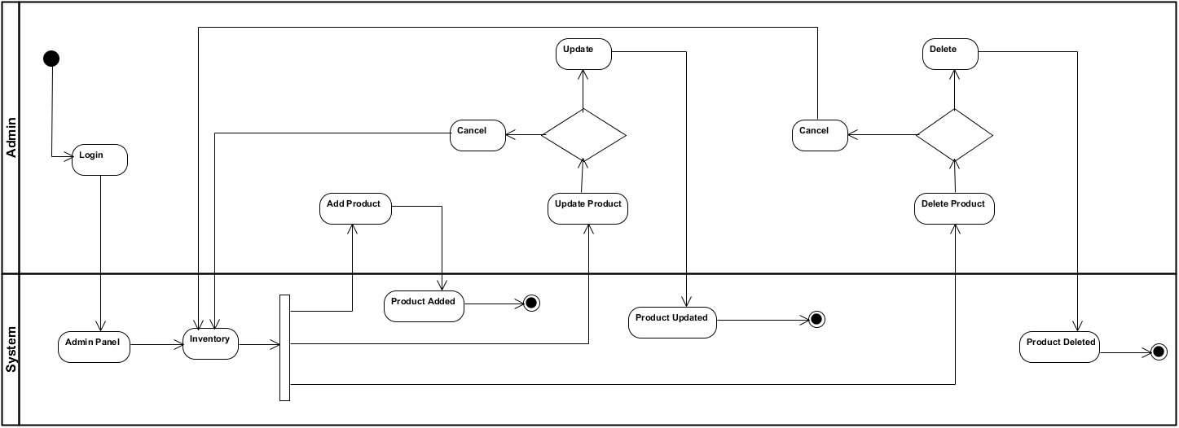

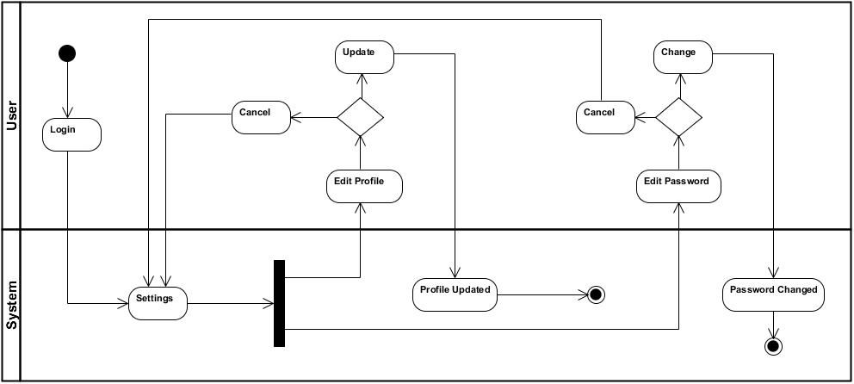

Strucural Modeling

Figure 8: Login Sequence Diagram

### Class Diagram:

Class diagram is a static diagram. It represents the static view of an application. Class diagram shows a collection of classes, interfaces, associations, collaborations, and constraints. It is also known as a structural diagram. (Anon., n.d.)

**Justifications:**

The Class Diagram is to model the static view of an application. It is forward and reverse engineering. Class diagrams are the only diagrams which can be directly mapped with object-oriented languages and thus widely used at the time of construction. It describes the responsibilities of a system.

**Advantages:**

* Class diagram are simple and fast to read.
* It gives you a sense of orientation.
* They provide detailed insight into the structure of our systems.

**Disadvantages:**

* They do not have dynamic model.
* It shows only collaboration among the elements of the static view.

### nitial Class Diagram:

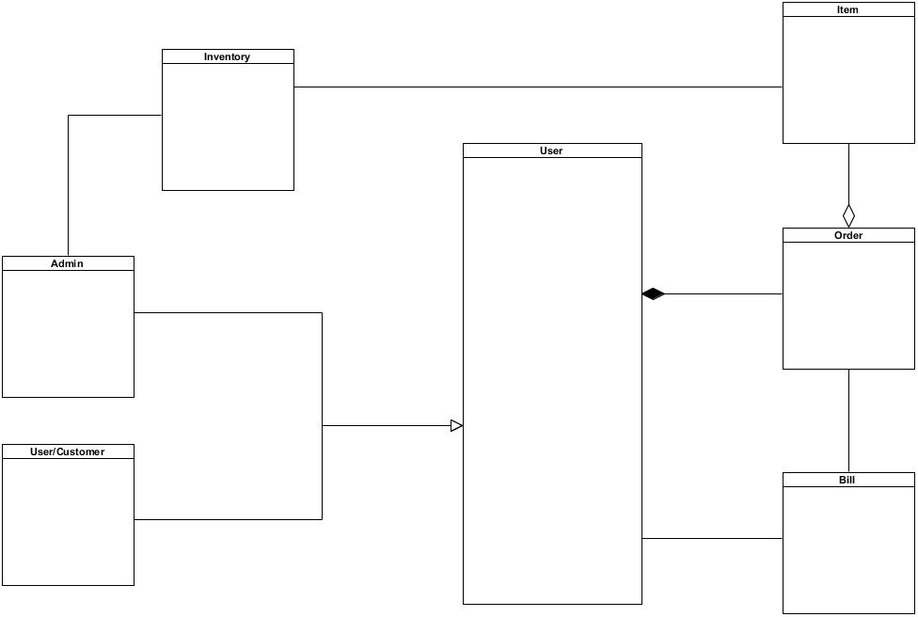

Figure 2: Initial Class Diagram

### inal Class Diagram:

Figure 3: Final class diagram

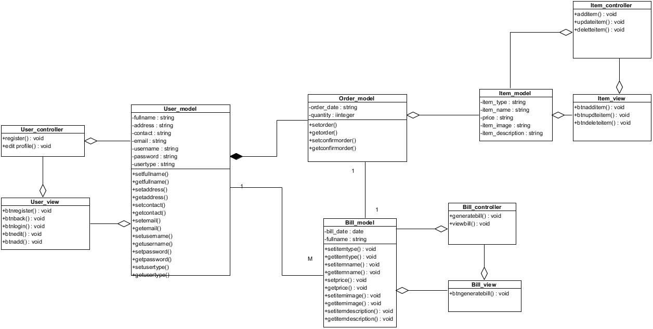

## Databse Modeling

### ER Diagram:

An **entity-relationship diagram (ERD**) is a data modeling technique that graphically illustrates an information system's entities and the relationships between those entities. An **ERD** is a conceptual and representational model of data used to represent the entity framework infrastructure.

**Justifications:**

The ER Diagram is to visualize database design ideas, so we have a chance to identify the mistakes and design flaws, and to make correction before executing the changes in database. By visualizing a database schema with an ERD, we have a full picture of the entire database schema through which we can easily locate entities, view their attributes and to identify the relationships they have with others.

**Advantages:**

* It is very simple if we know relationship between entities and attributes.
* It is better visual representation.
* It is an effective communication tool for database designer.

**Disadvantages:**

* It has limited constraints and specification.
* Information can be hidden in ER model.
* It is difficult to show data manipulation in ER model.

# 

Figure 4: ER Diagram

## UI Modeling (Prototype)

# Chapter 4: Implementation

## Framework

## UI Design:

### Home Page:

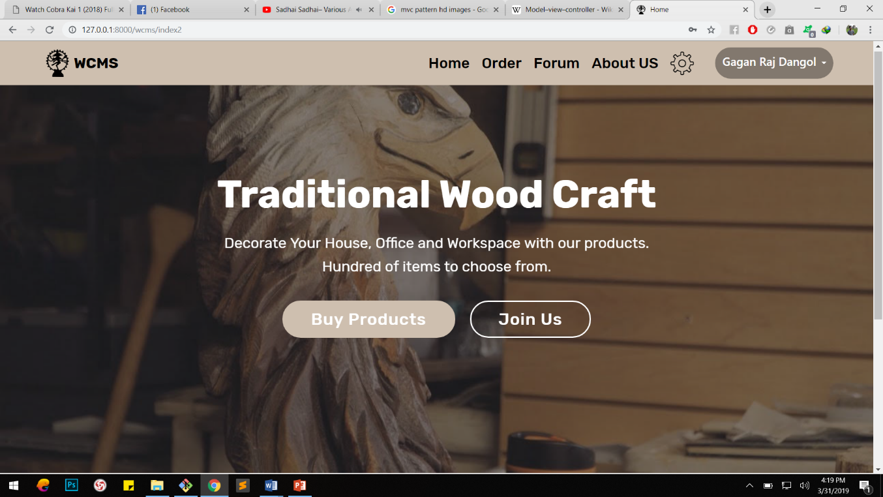

Figure 19: Home Page User Interface

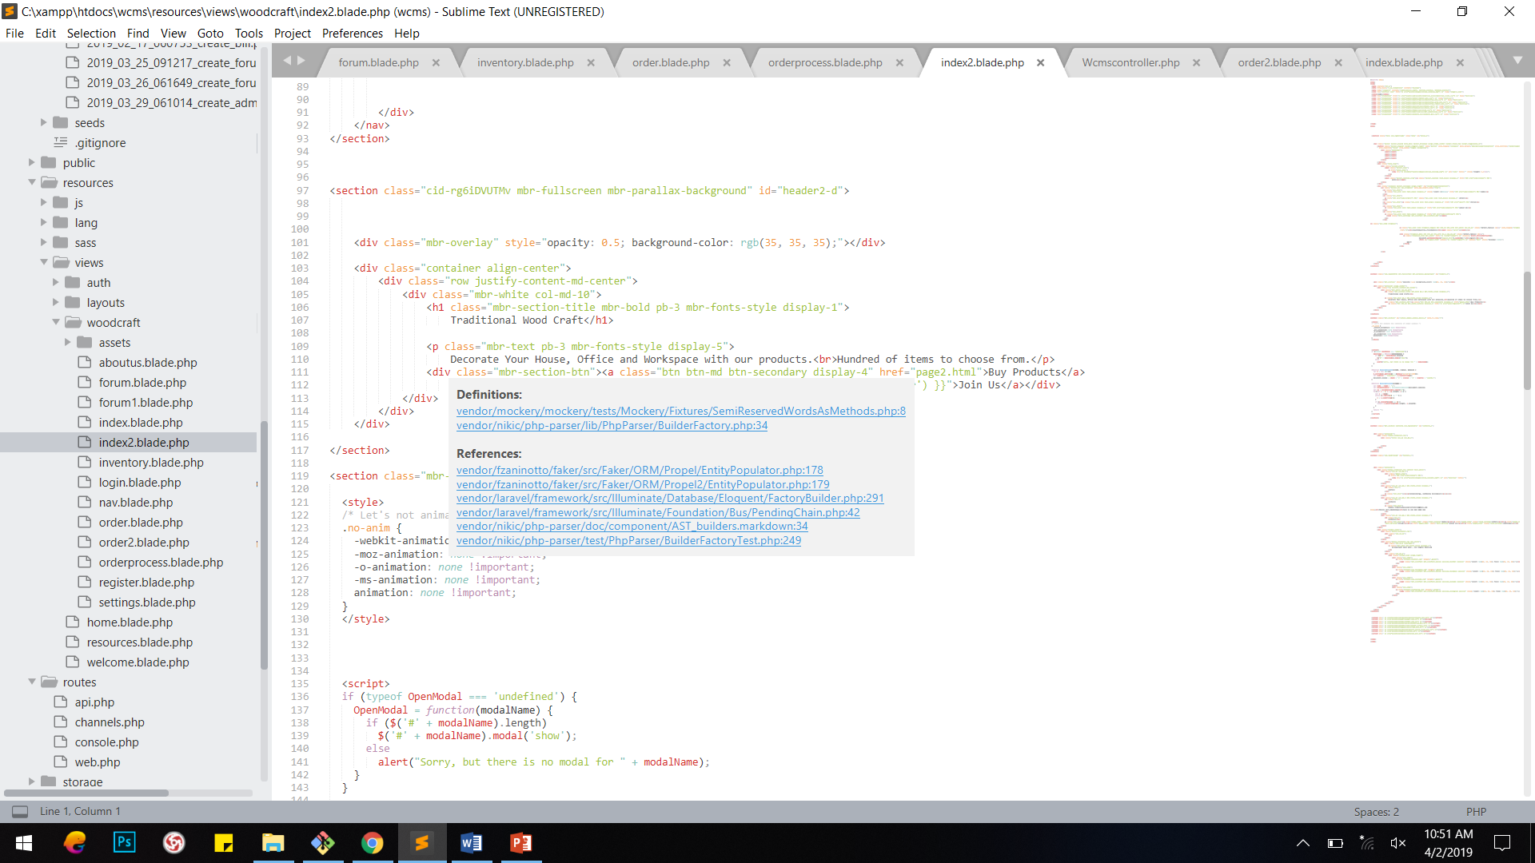

### Login Page:

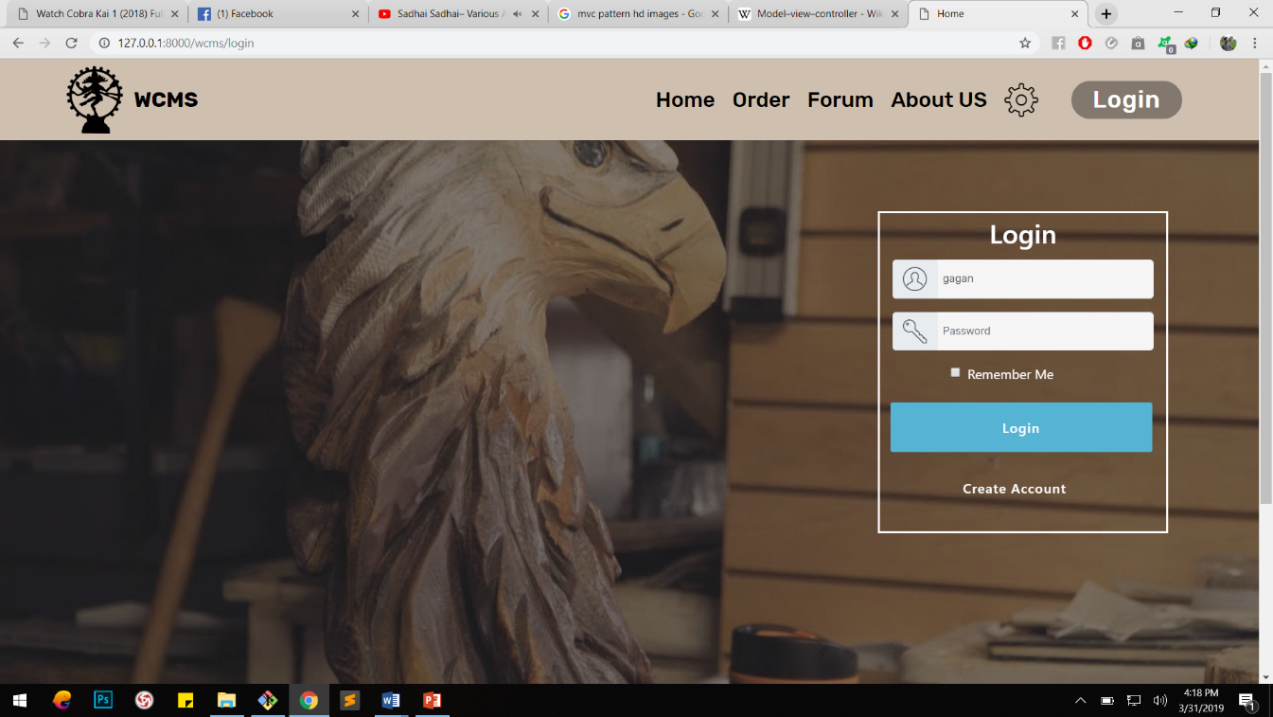

Figure 20: Login Interface

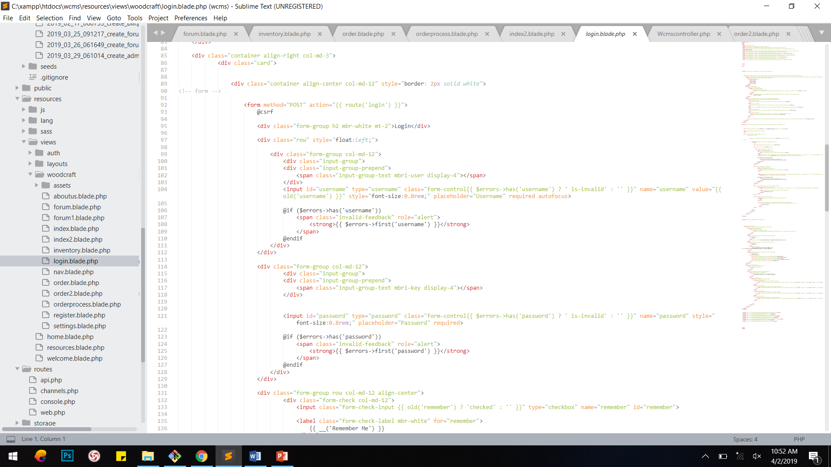

### Products Page:

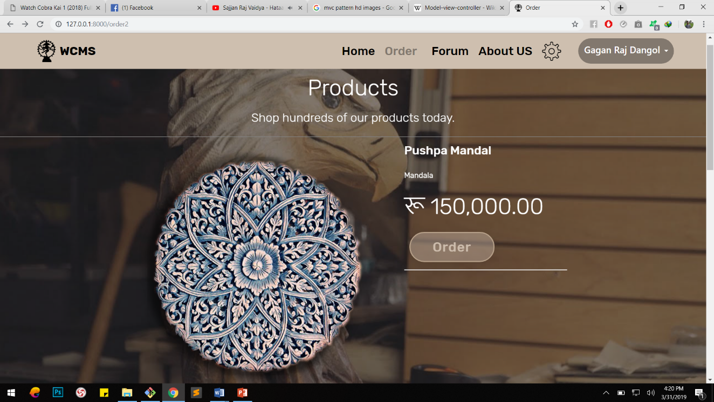

Figure 21: Products Interface

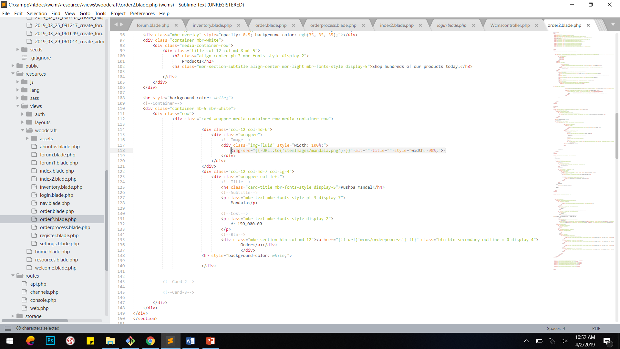

### Forum Page:

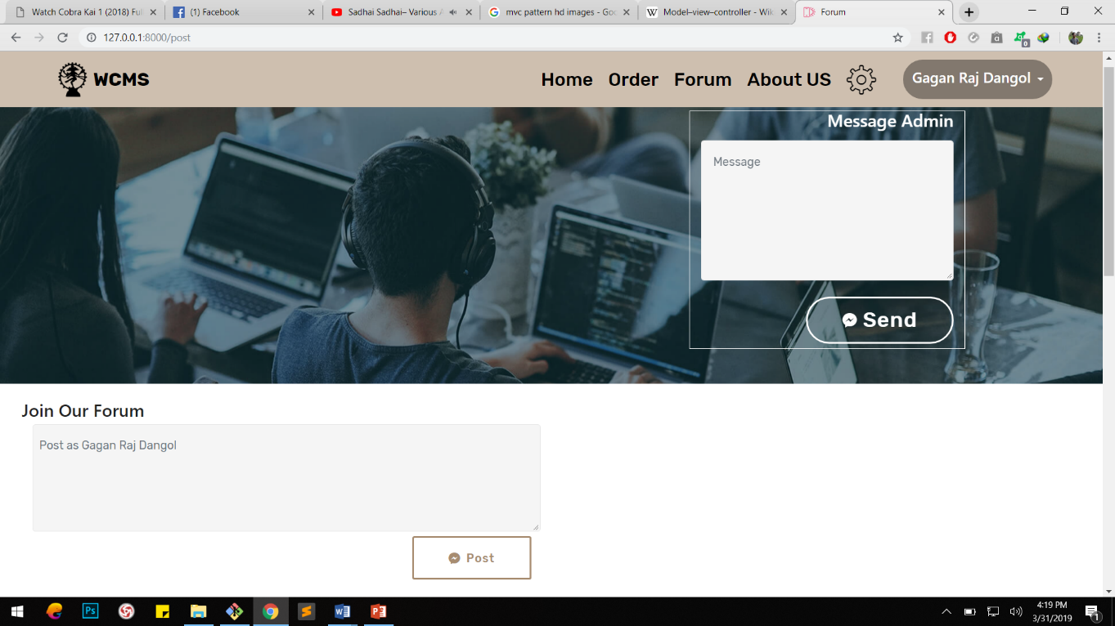

Figure 22: Categories Page User Interface

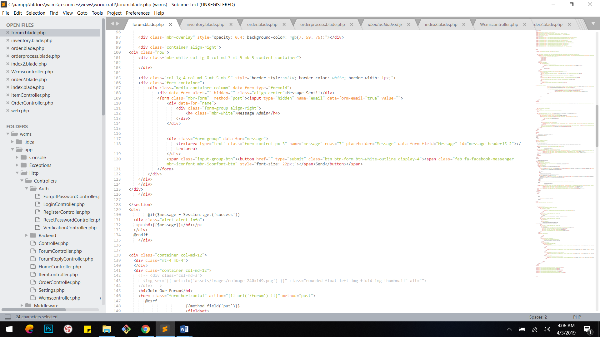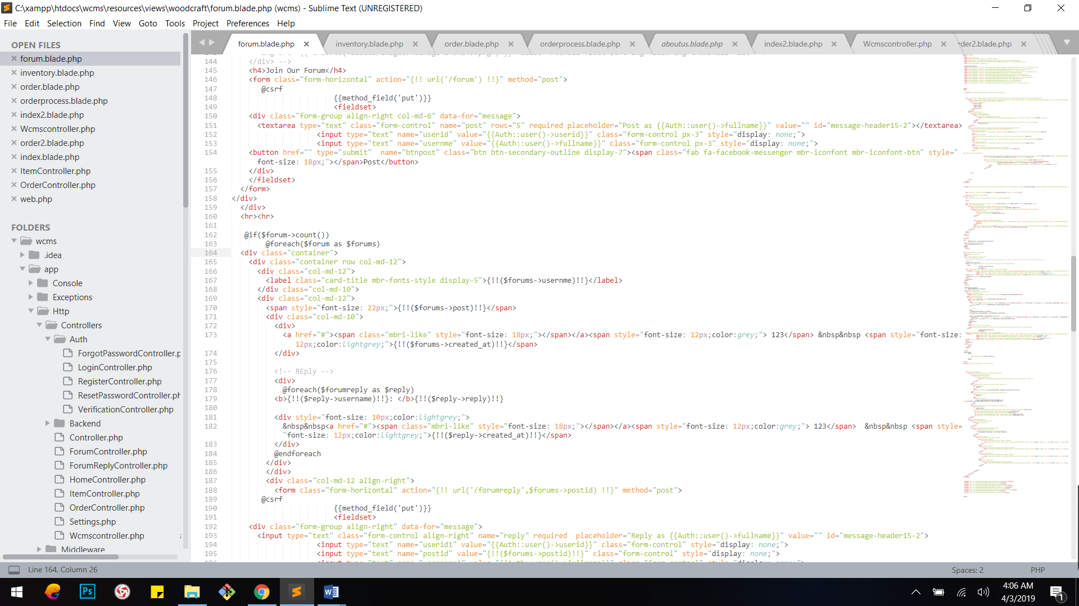

### Order page:

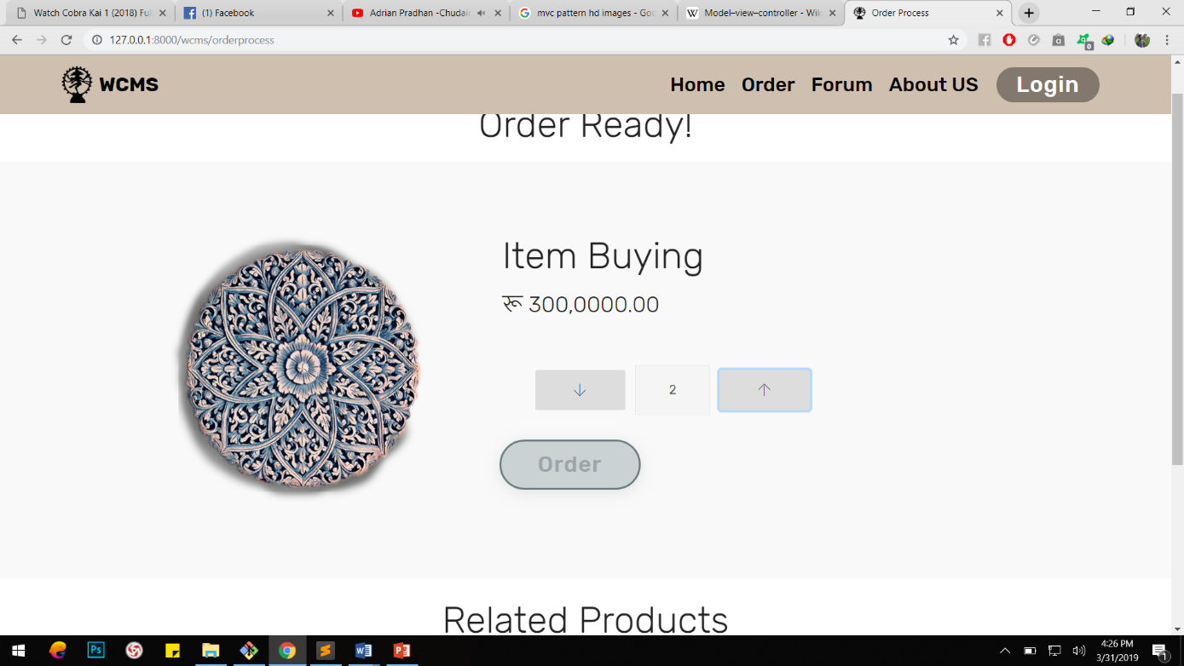

Figure 23: Sign Up Page

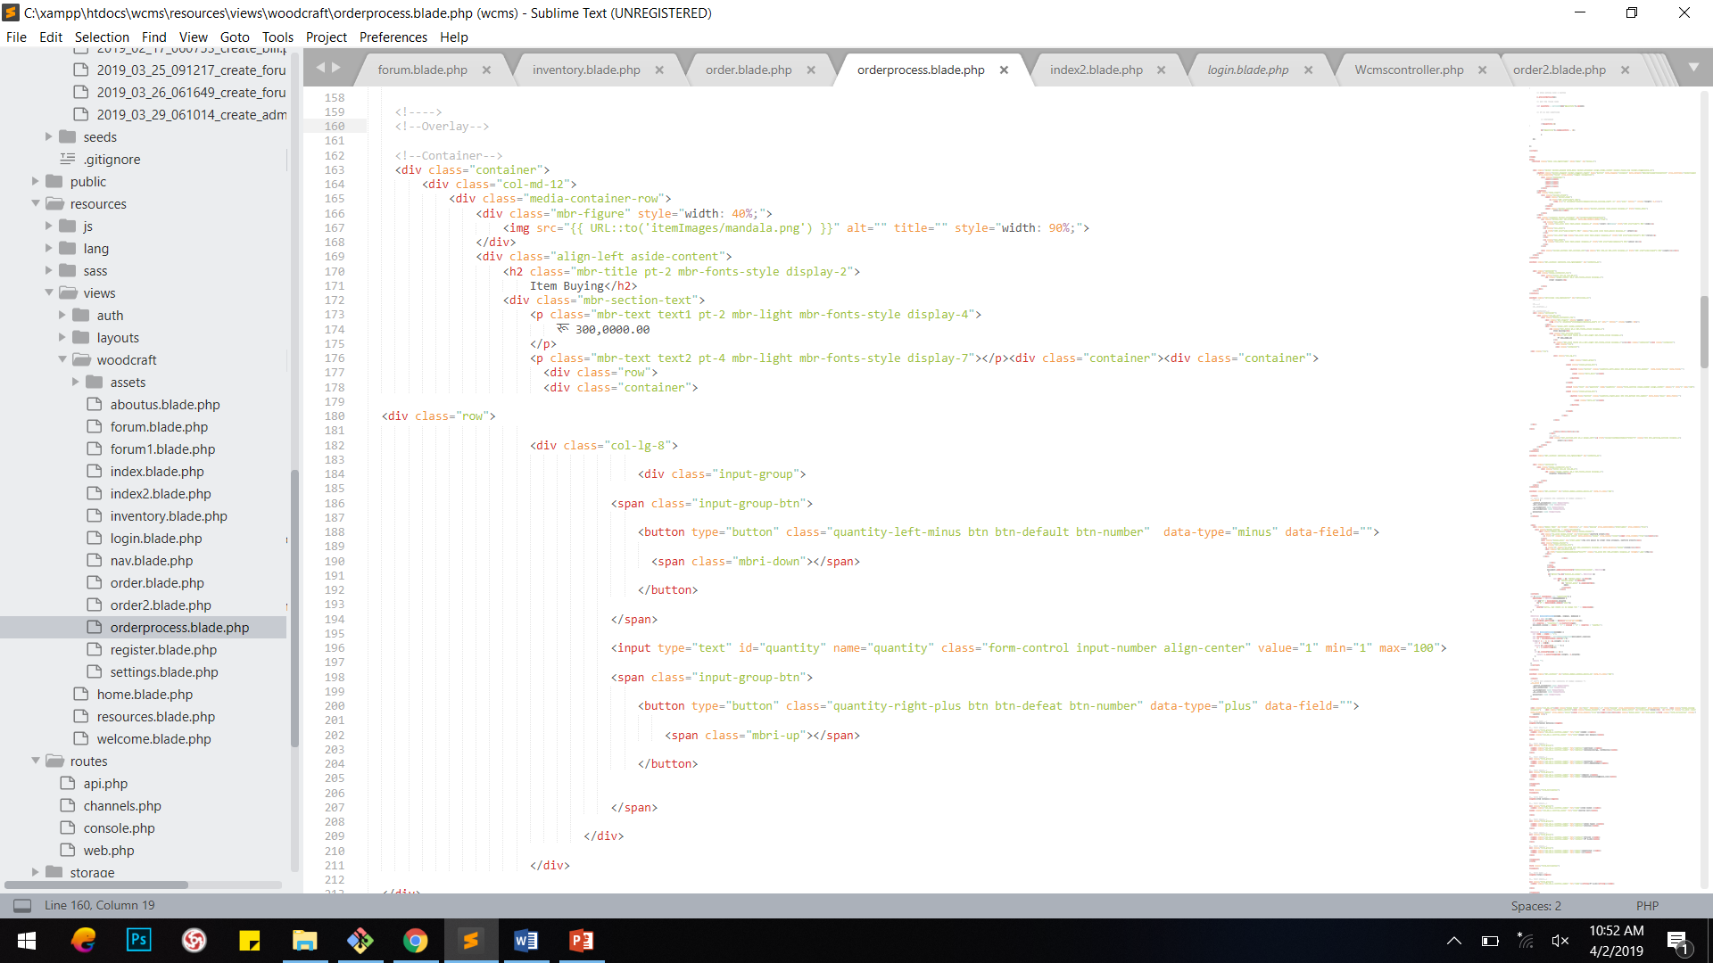

### About Us Page:

Figure 24: Billing page

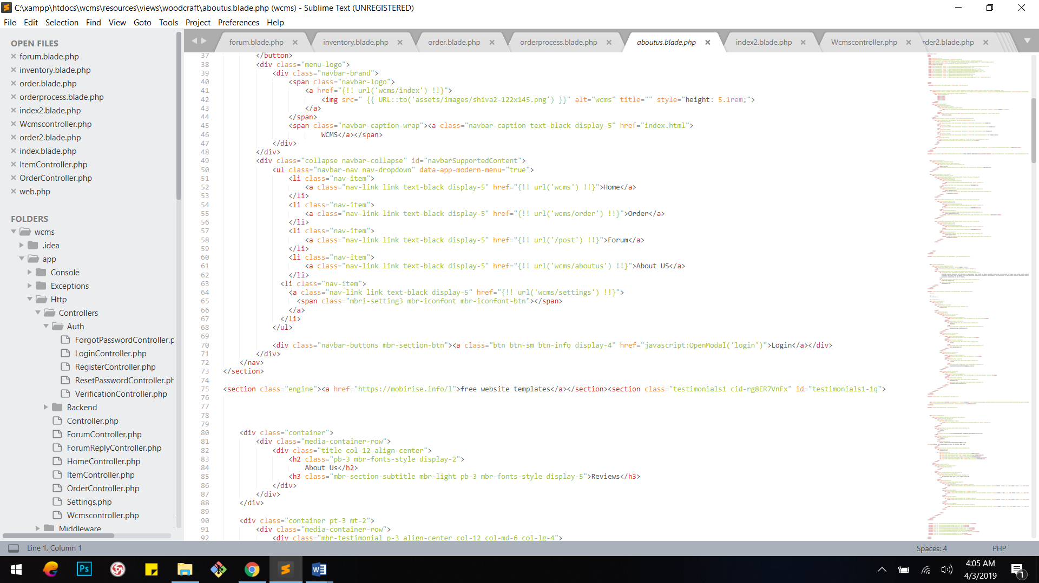

# Chapter 5: Testing

Testing is the process of evaluating the functionality of the software in order to check whether developed software met the actual requirement or not (Tutorial point, 2019). It identifies defects and errors made during development phase and ensures that the system is defect free. Also, it measures the quality of the product developed.

And testing is done in order to make sure customer’s reliability and their satisfaction with our developed software.

There are different types of testing to make sure it works as expected. Black box testing, Unit testing, White box testing, Acceptance testing etc. are types of testing. And among them I have performed **Unit testing** and **Black box testing** with test planning.

Test case or Test plan: It is the documentation of specific test with objectives, resource and process of testing.

## Unit Testing

Unit testing is the process of isolating a section of source code and executing each individual unit of source code to determine its correctness (Guru99, 2019). It is performed during the development of application.

Advantages of unit testing;

* Fix bugs in early development cycle.
* Improves the quality of code.
* Reduces defects and bugs.
* Less costly.

## Black box testing

Black box testing is the process of examining the functionality of the system through user interface without knowing the working of internal structure (Guru99, 2019). It only focuses on inputs and outputs of the software system.

Advantages of black box testing;

* Validates the functional requirement.
* Test can be done through end user’s point of view.
* No need of technical person for testing.

1. URL

|  |  |
| --- | --- |
| Test case no. | T1 |
| Purpose of the case | Exploring Home Page |
| Test data | url: 127.0.0.1:8000 |
| Class name | UnitTest |
| Function name | testURL |
| Expected result | Open home page |
| Actual result | Open home page (index) |
| Conclusion | Actual results matches the expected results |

Unit Testing

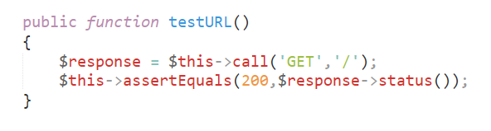

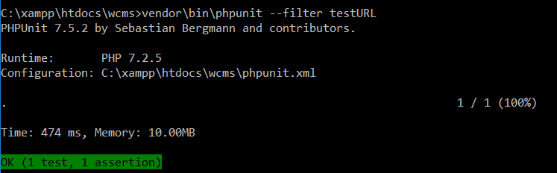

Black boxTesting



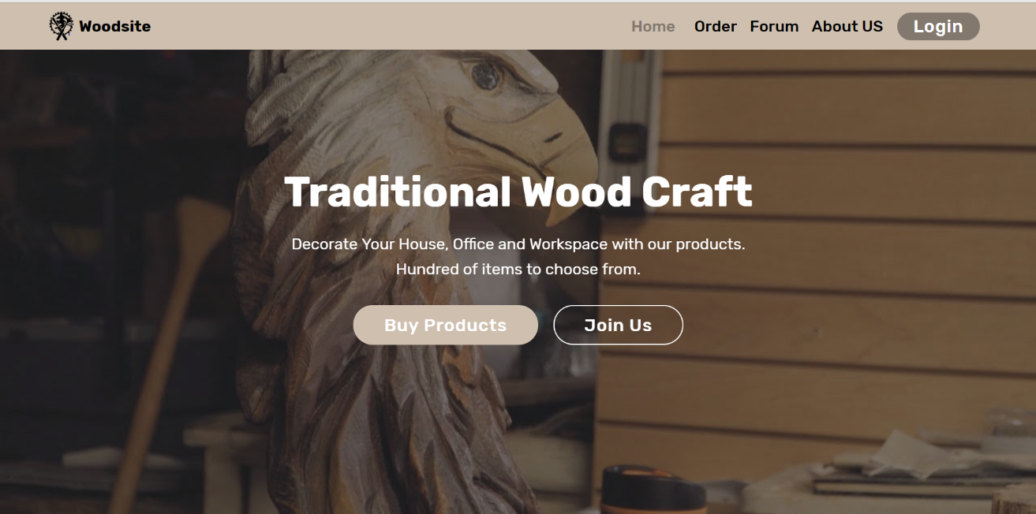

1. Registration

|  |  |
| --- | --- |
| Test case no. | T2 |
| Purpose of the case | Registering new user |
| Test data | fullname: Gagan Raj Dangol  address: Khokana, Lalitpur  contact: 9860058411  email:dangolgrozen123@gmail.com  username: gagan  password: gagrangol |
| Class name | UnitTest |
| Function name | testRegistration |
| Expected result | Register and go to login page |
| Actual result | Register and go to login page |
| Conclusion | Actual results matches the expected results |

UnitTesting

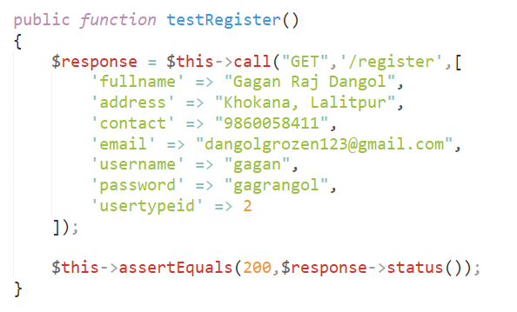

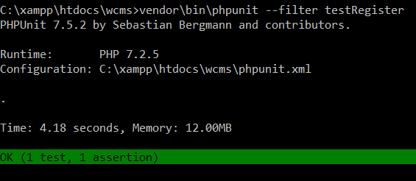

## Black box Testing

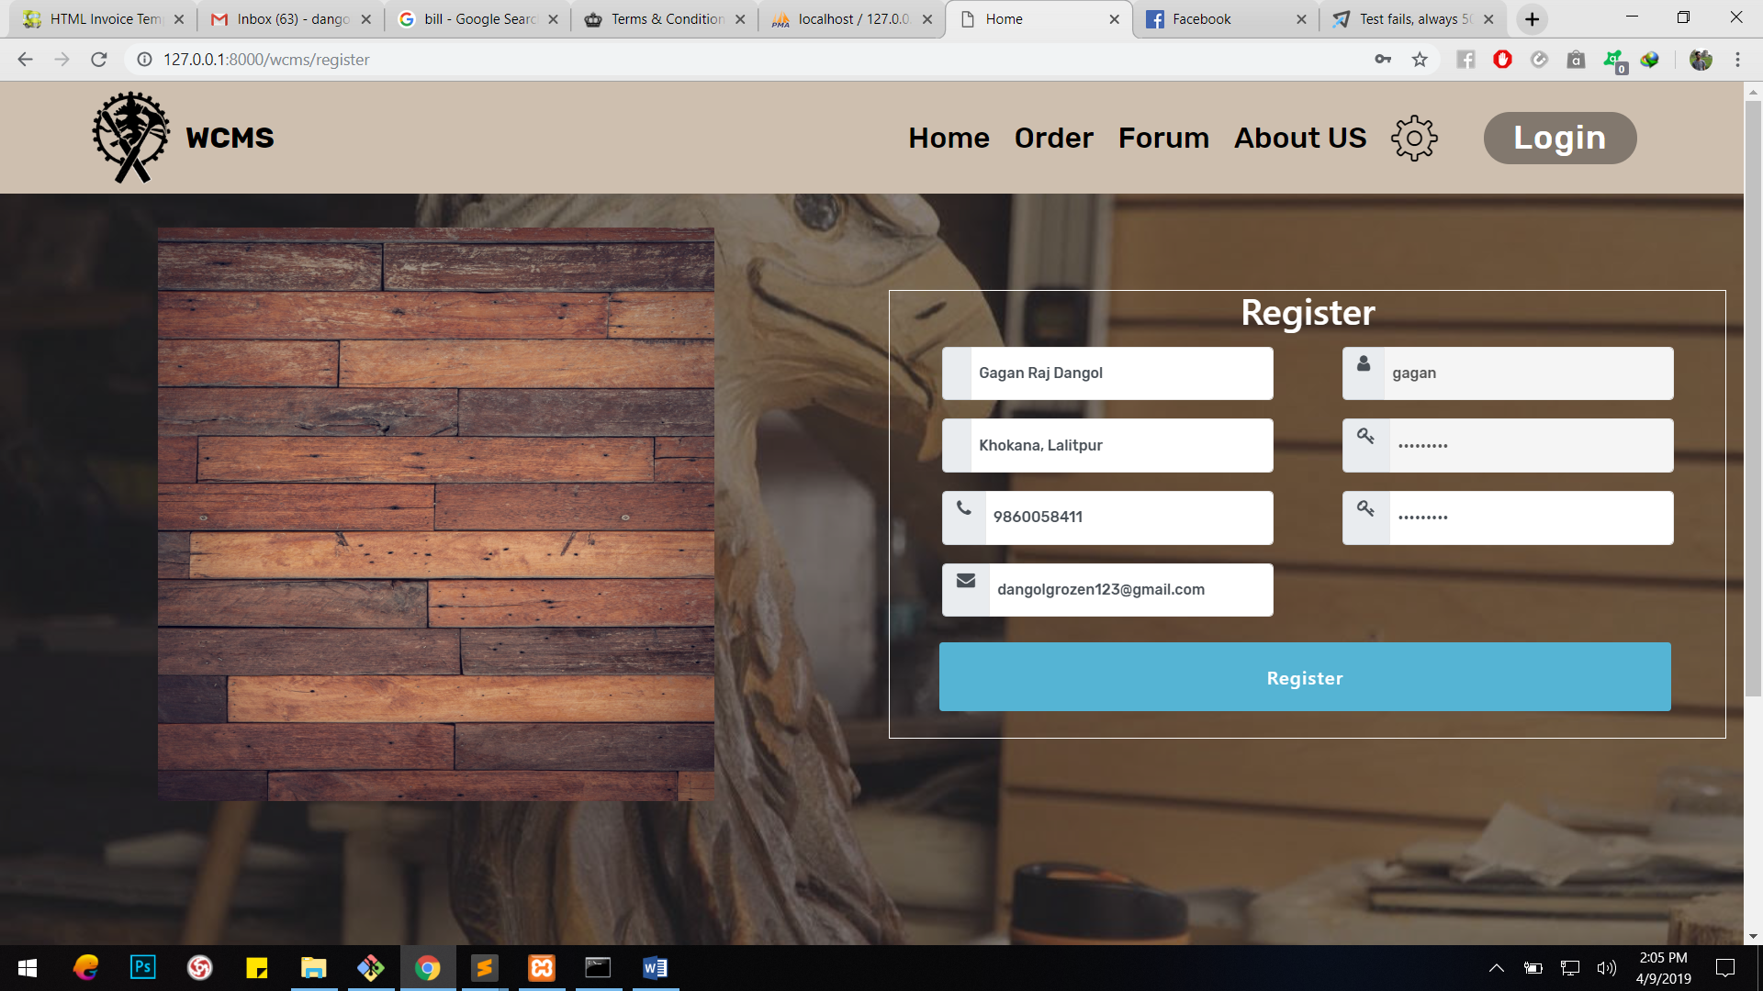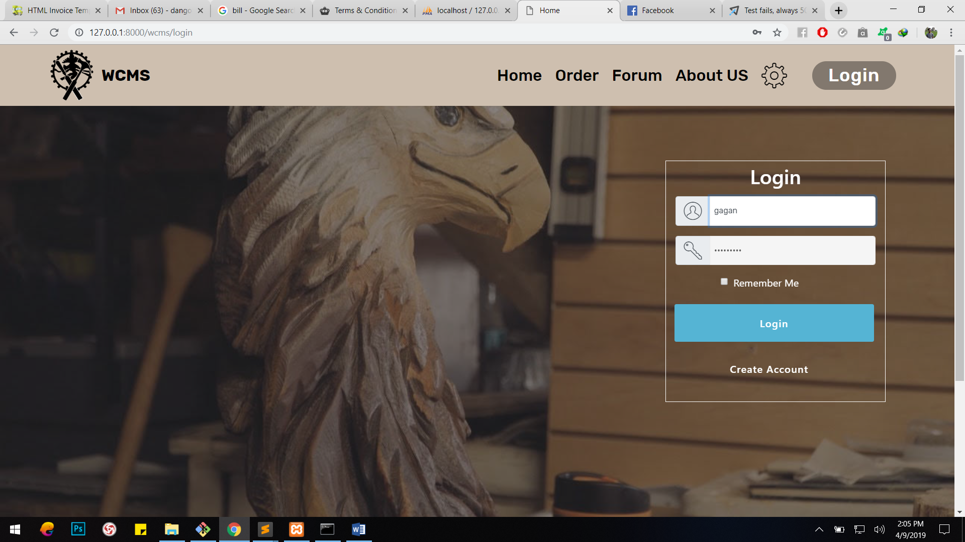

1. Login

|  |  |
| --- | --- |
| Test case no. | T3 |
| Purpose of the case | Login to the site |
| Test data | username: gagan  password: gagrangol |
| Class name | UnitTest |
| Function name | testLogin |
| Expected result | Login and go to index |
| Actual result | Login and go to index |
| Conclusion | Actual results matches the expected results |

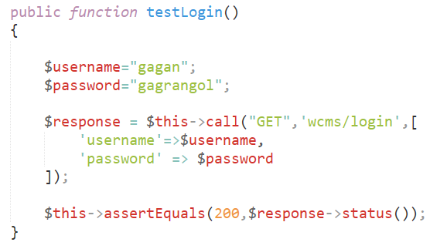 UnitTesting

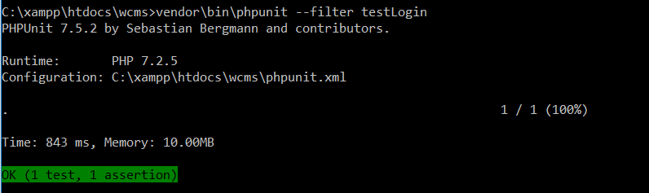

****BlackboxTesting

|  |  |
| --- | --- |
| Test case no. | T4 |
| Purpose of the case | Inserting new item |
| Test data | item_name: Ganesh  item_type: C  price: 12000  item_description: Idol |
| Class name | UnitTest |
| Function name | testAddItem |
| Expected result | Add item and go to inventory |
| Actual result | Add item and go to inventory |
| Conclusion | Actual results matches the expected results |

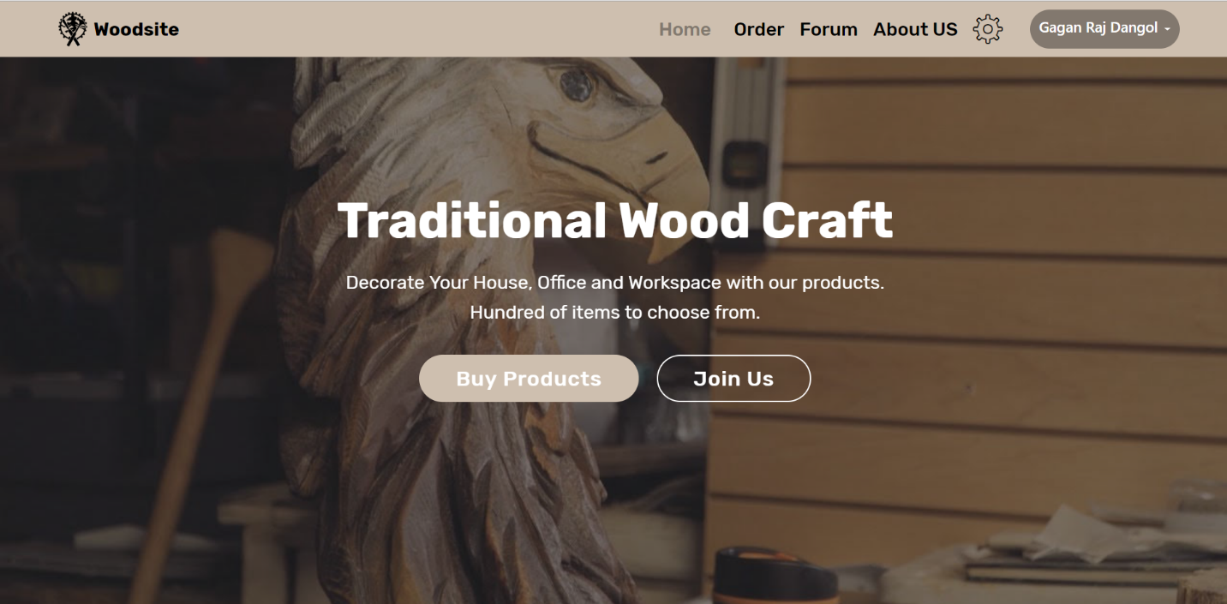

1. Add Item

UnitTesting

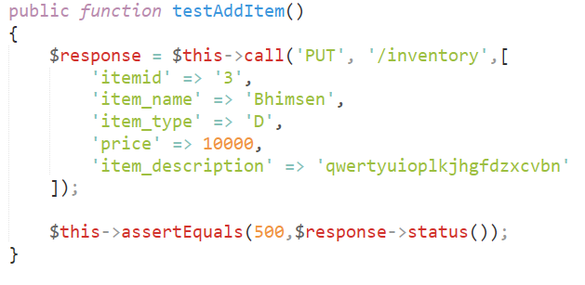

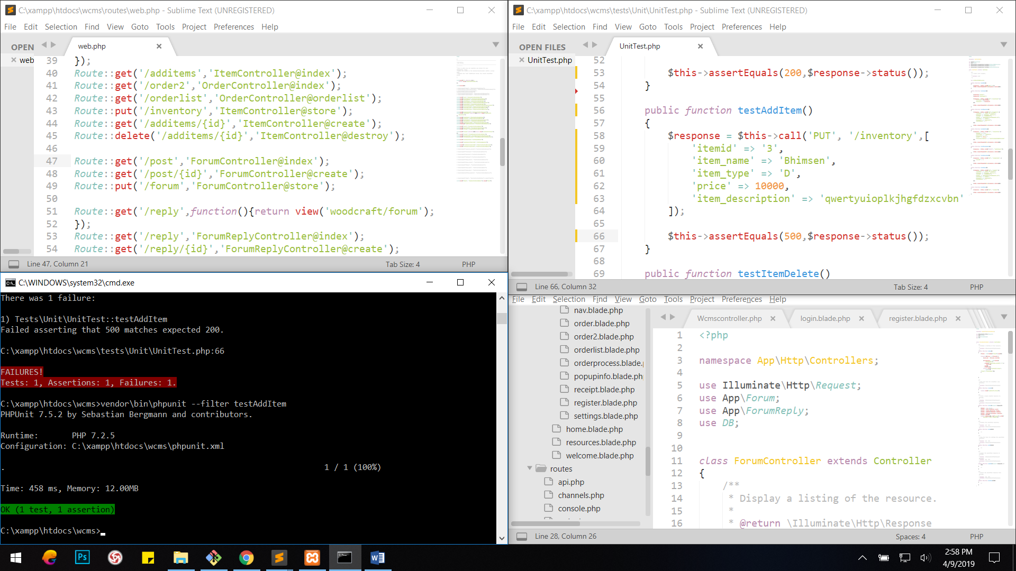

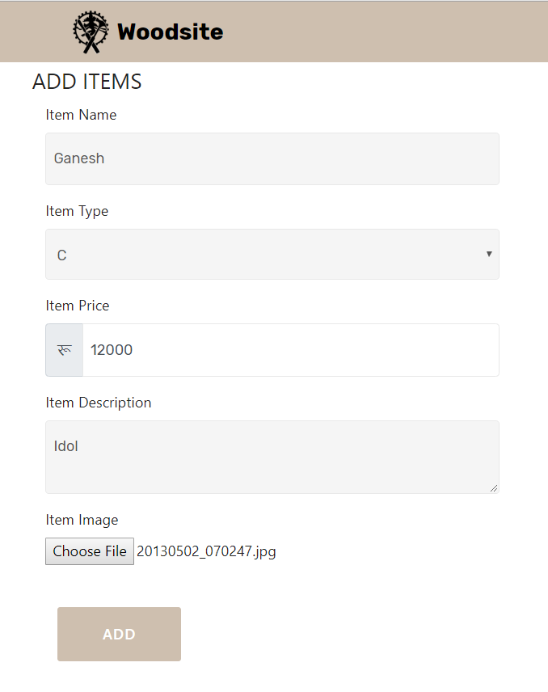

BlackBoxTesting

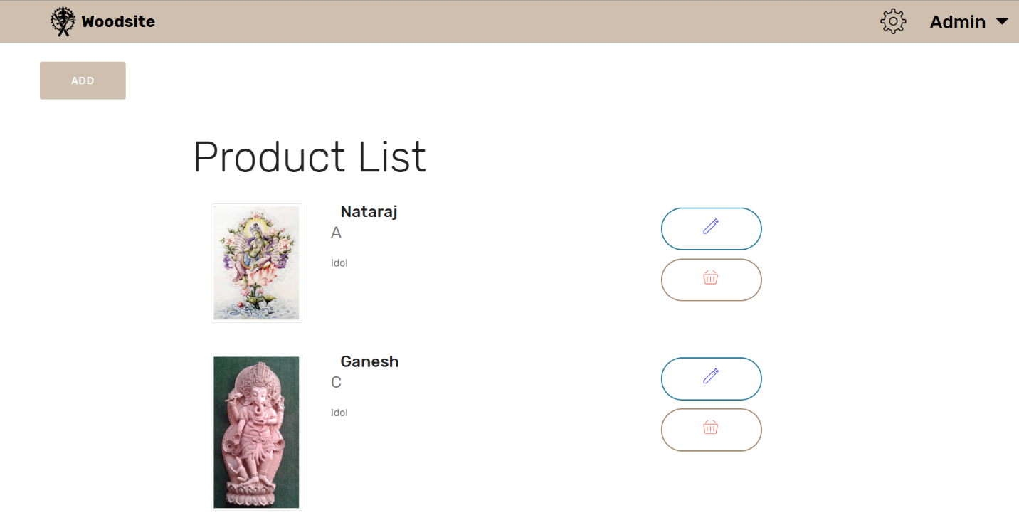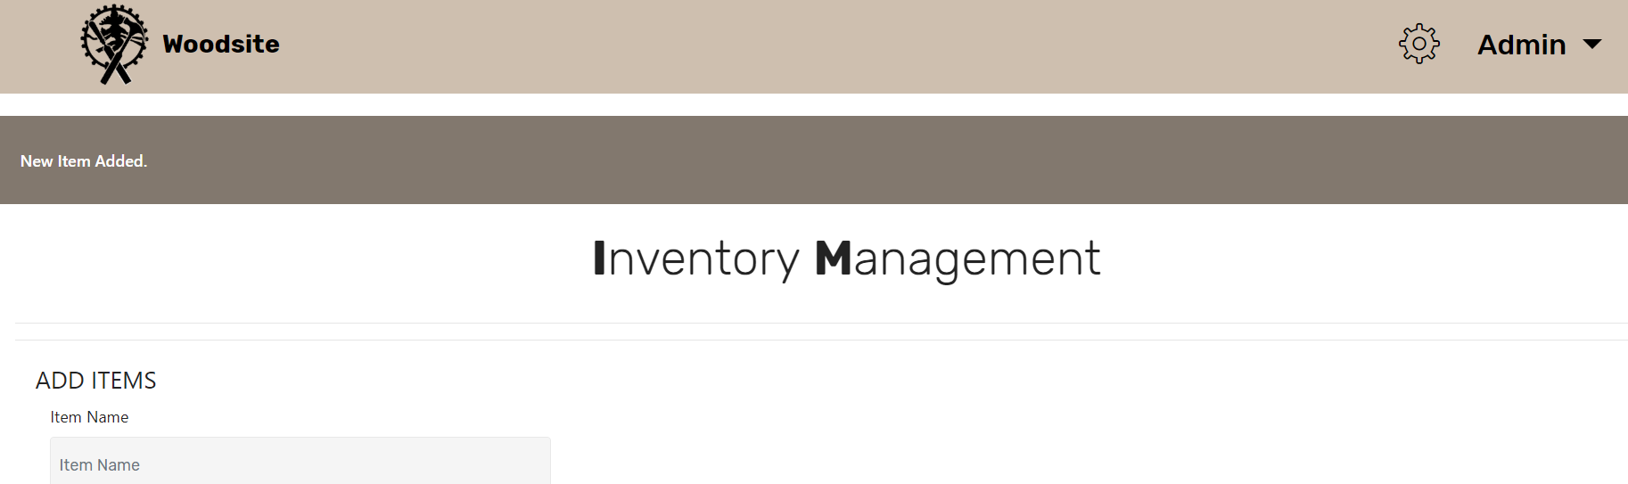

1. Delete Item

|  |  |
| --- | --- |
| Test case no. | T5 |
| Purpose of the case | Deleting an item |
| Test data | Itemid: 2 |
| Class name | UnitTest |
| Function name | testDeleteItem |
| Expected result | Delete item |
| Actual result | Delete item |
| Conclusion | Actual results matches the expected results |

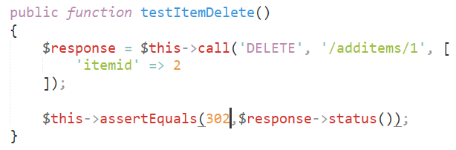

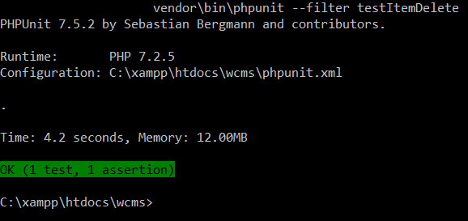

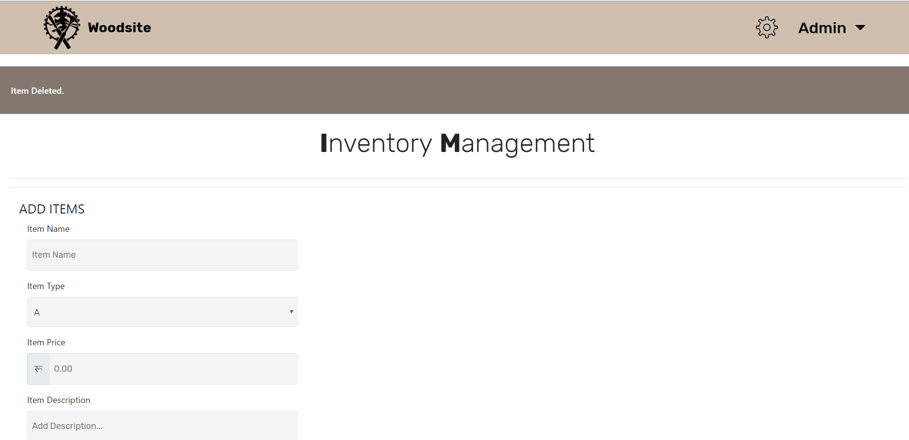BlackBoxTesting

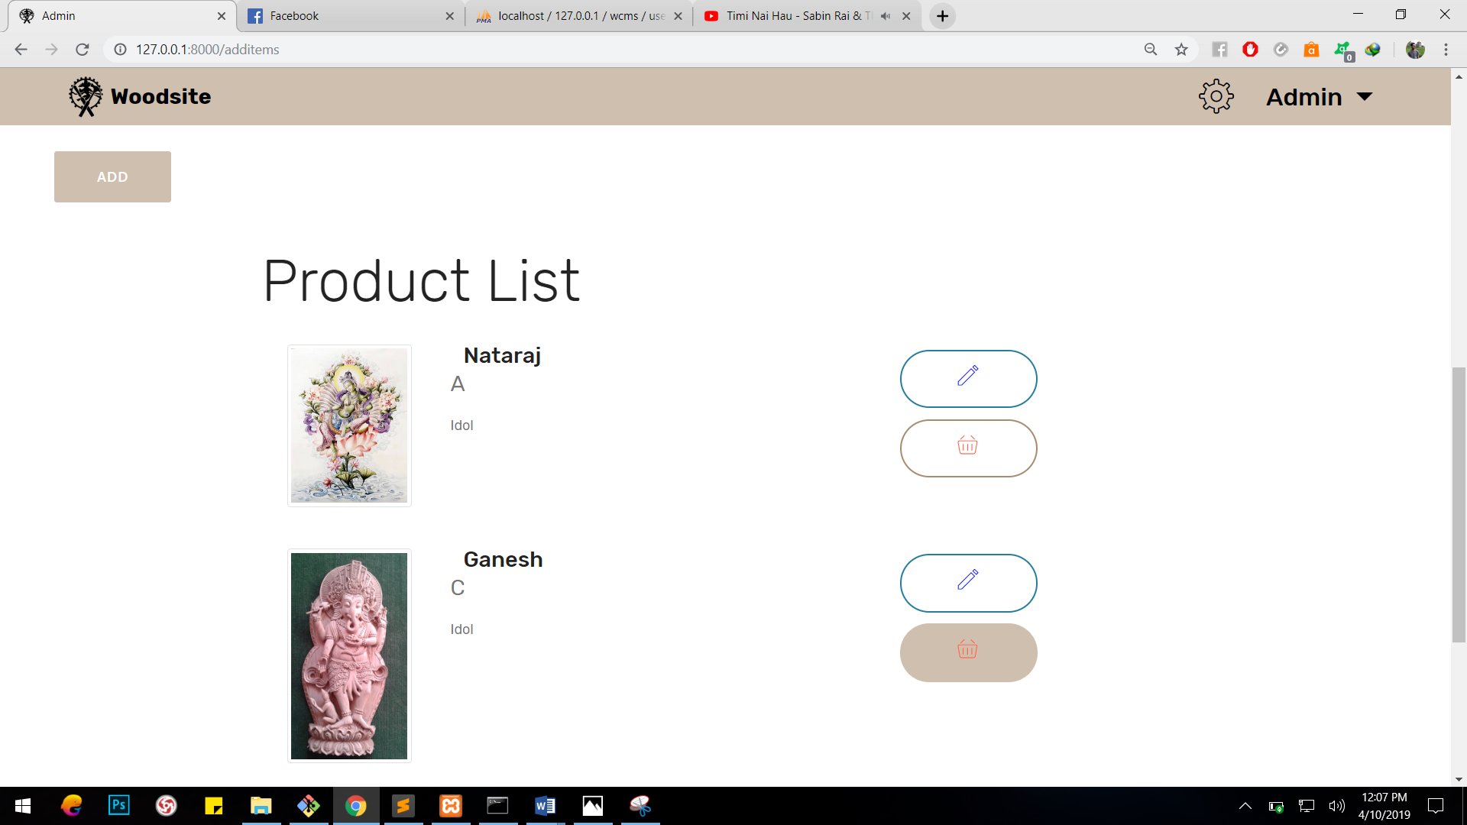

|  |  |
| --- | --- |
| Test case no. | T6 |
| Purpose of the case | fetching data from item table to all users |
| Test data | No data |
| Class name | UnitTest |
| Function name | testItems |
| Expected result | Display item data |
| Actual result | Display item data |
| Conclusion | Actual results matches the expected results |

1. Items

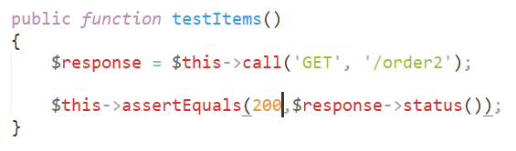

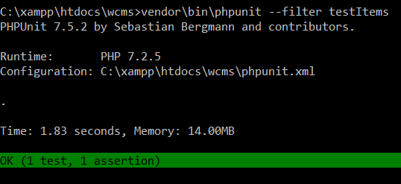

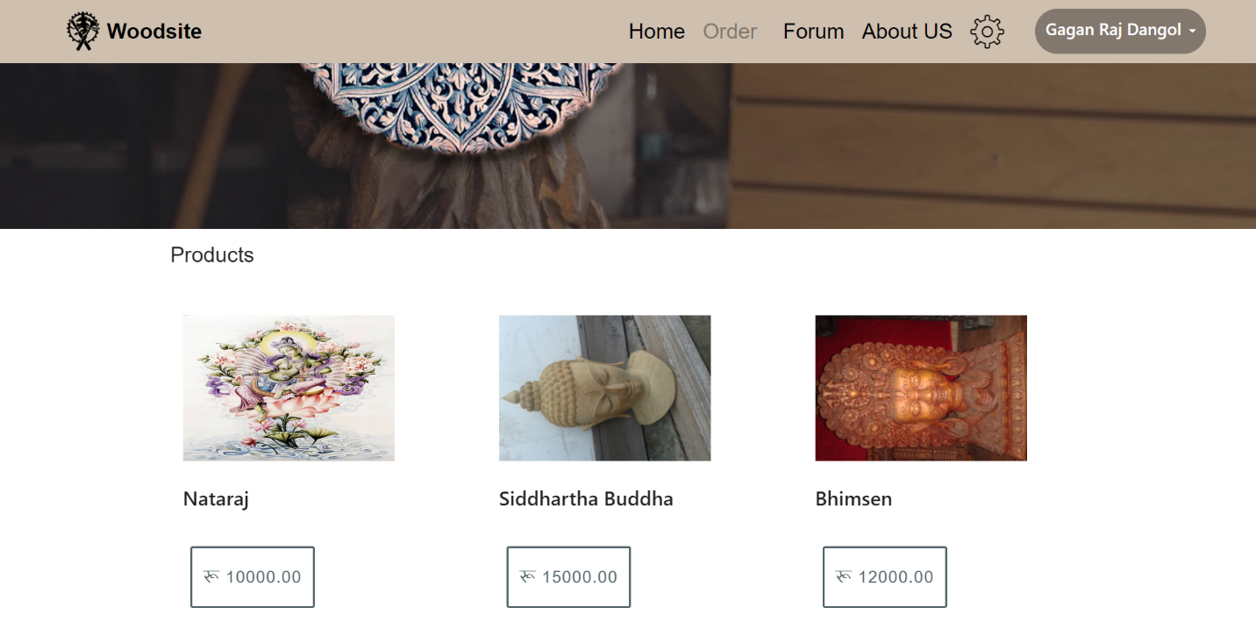

1. Order Process

|  |  |
| --- | --- |
| Test case no. | T7 |
| Purpose of the case | fetch item data of particular item to particular user |
| Test data | No data |
| Class name | UnitTest |
| Function name | testOrde |
| Expected result | fetch item data |
| Actual result | fetch item data |
| Conclusion | Actual results matches the expected results |

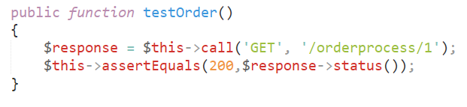

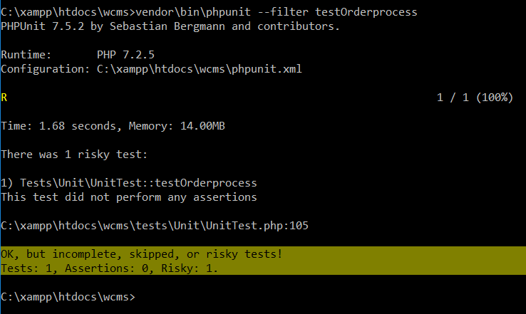

1. Order

|  |  |
| --- | --- |
| Test case no. | T8 |
| Purpose of the case | inserting data into order table |
| Test data | order_date: 2019-04-09  quantity: 3  userid: 2  Itemid: 1 |
| Class name | UnitTest |
| Function name | testOrderProcess |
| Expected result | insert order |
| Actual result | insert order |
| Conclusion | Actual results matches the expected results |

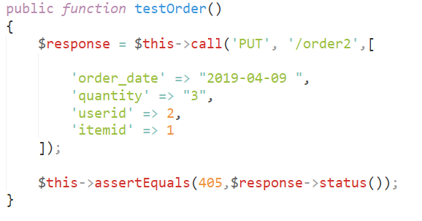

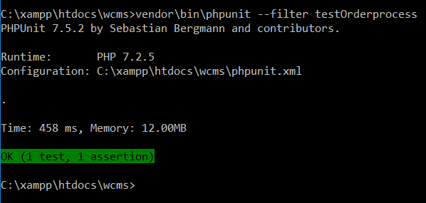

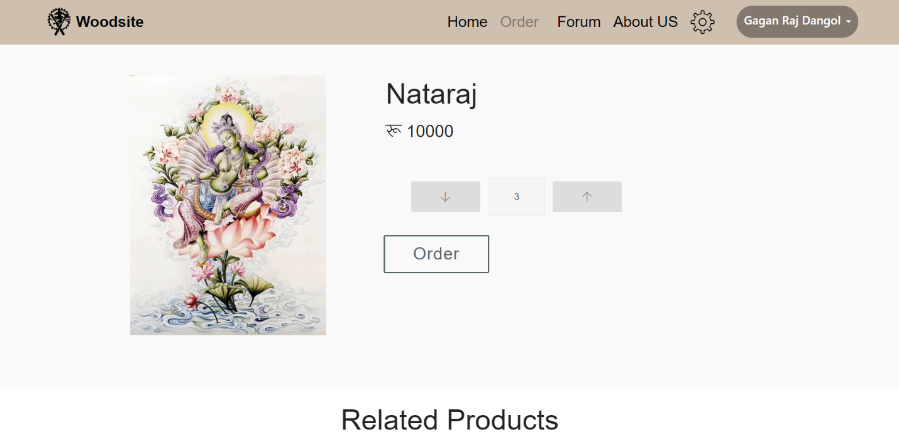Black BoxTesting

1. Order List

|  |  |
| --- | --- |
| Test case no. | T8 |
| Purpose of the case | Fetching order data to particular user |
| Test data | userid: 2  item: 1 |
| Class name | UnitTest |
| Function name | testOrderlist |
| Expected result | Display orderlist |
| Actual result | Display orderlist |
| Conclusion | Actual results matches the expected results |

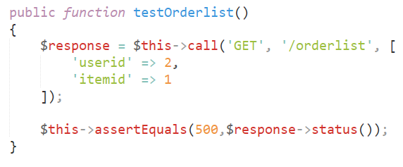

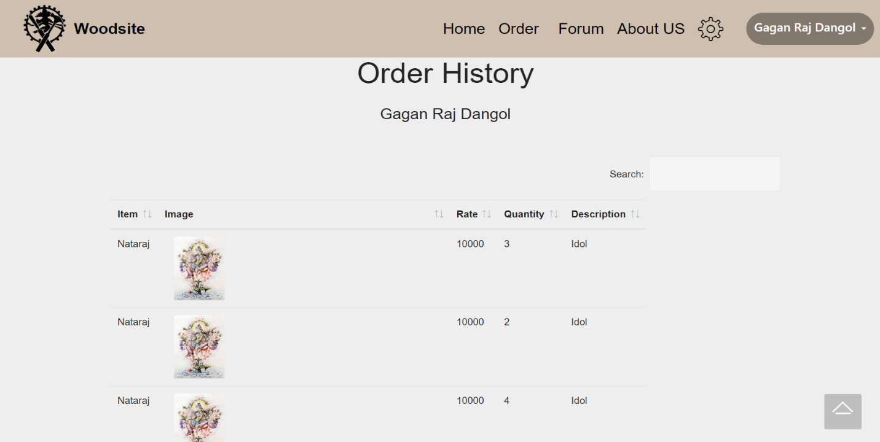BlackBoxTesting

1. Forum

|  |  |
| --- | --- |
| Test case no. | T8 |
| Purpose of the case | Fetching data from frum table to all users |
| Test data | Postid: 1 |
| Class name | UnitTest |
| Function name | testOrderlist |
| Expected result | Display forum data |
| Actual result | Display forum data |
| Conclusion | Actual results matches the expected results |

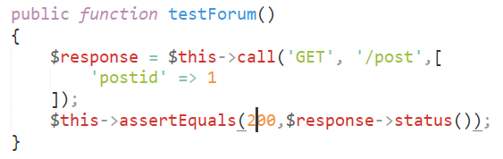

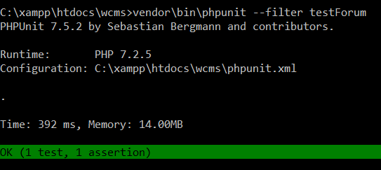

BlackBoxTesting

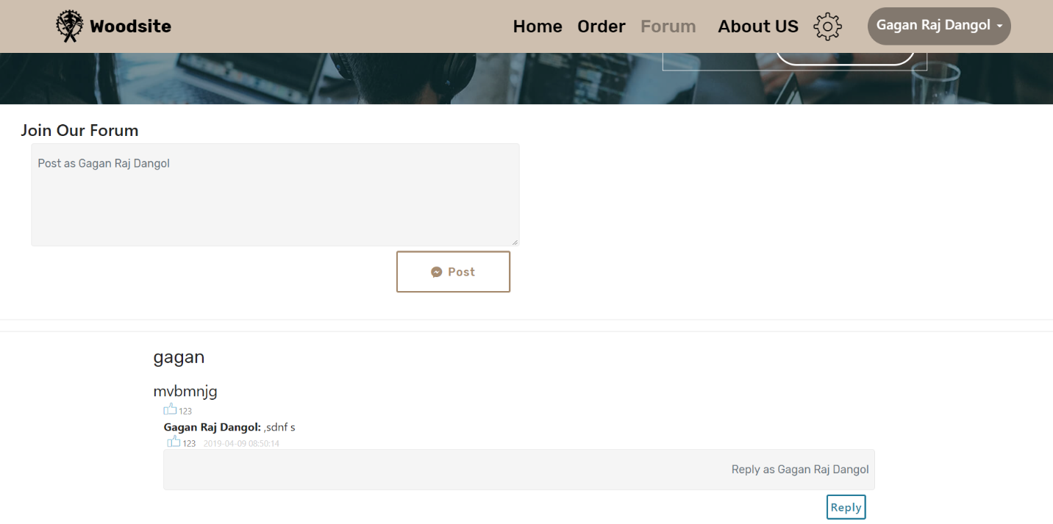

# Chapter 6: Other Project Issues

## Risk Management

Risk management refers to the process of identifying potential risks in advance, analyzing them and taking precautionary steps to reduce the risk.

Risk management is held in following ways:

* Risk Identify
* Risk Analyze
* Risk Rank or Evaluate
* Risk Treatment
* Risk Review and Monitor

The impacts that can cause on the project due to the risks is calculated as:

Impact = Likelihood * Consequence

Risk Likelihood values are shown as follows

|  |  |
| --- | --- |
| Likelihood | Value |
| Low | 1 |
| Medium | 2 |
| High | 3 |

Table 2: Likelihood measurement

Risk Consequence values are shown below

|  |  |
| --- | --- |
| Consequence | Value |
| Very low | 1 |
| Low | 2 |
| Medium | 3 |
| High | 4 |
| Very High | 5 |

Table 3: Consequences measurement

Risk Management

|  |  |  |  |  |  |
| --- | --- | --- | --- | --- | --- |
| S. N | Risks | Likelihood | Consequences | Impact | Solution |
| 1 | Change in Requirements | 3 | 4 | 12 | thorough requirement analysis and contract negotiation |
| 2 | Database Failure | 1 | 5 | 5 | Proper data backup in external mediums |
| 3 | Denial of Service attack (DOS) | 2 | 4 | 8 | Installation of reliable security system and firewall |
| 4 | Ransomware | 1 | 5 | 5 | Proper data backup and strong system |
| 5 | Viruses and Malwares | 1 | 3 | 3 | Installation of strong anti-virus and anti-malware software. |
| 6 | Lack of Resources | 2 | 3 | 6 | operation in limited resources or extension of resources |
| 7 | Natural Disasters | 3 | 4 | 12 | Data backup, weather news follow up and insurance |

## Configuration Management

Configuration Management is the task of tracking and controlling changes in the software, to systematically manage, organize and control the changes in the documents, codes and other entities during development of software. It aims to control cost and work effort involved in making changes to the application or the entire system. The primary aim of configuration management is to increase productivity with lesser mistakes. The given figures shows the configuration management process of this project.

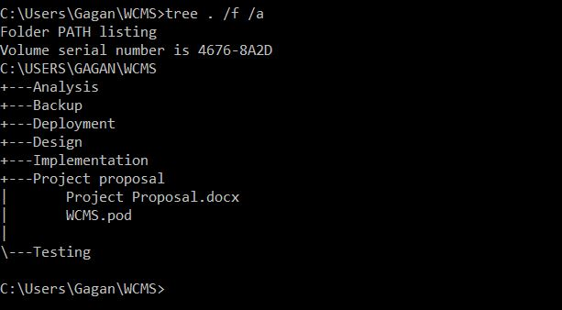

# Chapter 7: Conclusion

In this part, I have completed the analysis phase of developing software. In the completion of this phase, we have outcome the requirements, database model and user interface.

# Chapter 8: References

Anon., n.d. [Online]   
Available at: https://www.tutorialspoint.com/uml/uml_class_diagram.htm

Anon., n.d. [Online]   
Available at: https://www.tutorialspoint.com/uml/uml_use_case_diagram.htm

Anon., n.d. [Online]   
Available at: https://www.tutorialspoint.com/uml/uml_activity_diagram.htm

Anon., n.d. *stack overflow.* [Online]   
Available at: https://stackoverflow.com/questions/16475979/what-is-the-difference-between-functional-and-non-functional-requirement

# Chapter 9: Appendix